**Hong Kong Institute of Vocational Education**

**Department of Information Technology (Tsing Yi)**

**HD in Software Engineering**

**ITP4522 Software Project Management &**

**Quality Assurance (SPMQA) (2021/2022)**

**Design Specification Report**

|  |  |  |
| --- | --- | --- |
| **Student** | **Contribution to the project (%)**  **(Total 100%)** | **Signature** |
|  |  |  |
| **MAK Chi Wang**  **(210045798)** | **50%** |  |

We declare that this is a group project and that no part of this submission has been copied from any other student’s work or from any other source except where due acknowledgement is made explicitly in the text, nor has any part been written for us by another person.

Table of Content

1. Detail design of the system 3

1.1. Actor Specification 3

1.2. Use Case 5

**1.2.1.** **Login System** 5

**1.2.2.** **POS System** 7

**1.2.3.** **System For Sales Department** 13

**1.2.4.** **System For Inventory Department** 19

**1.2.5.** **System For Technical Support Department** 30

**1.2.6.** **System For Purchasing Department** 35

**1.2.7.** **System For Accounting Department** 39

**1.2.8.** **Online Store (Web & Mobile App)** 44

2. Structure Chart 52

3. Sequence Diagram 53

3.1. Login And Logout 53

3.2. POS (Credit Card Payment) 53

3.3. POS Place Order (Digital Payment) 54

3.4. POS Place Goods Return Note 55

3.5. Checking 56

3.6. Re-stock And Re-order Request 57

3.7. Place Goods Received Note 57

3.8. Delivery And Installation Timetable Arrangement 58

3.9. Place Purchase Order 58

3.10. Data Analysis 58

3.11. Register and buy goods with credit card (Online Store) 59

3.12. Register and buy goods with digital payment (Online Store) 60

4. UI 61

4.1. System 61

4.2. Application For Mobile And Tablet 71

4.3. Online Store 79

1. Detail design of the system
   1. Actor Specification

|  |  |
| --- | --- |
| **Actor name** | **Description** |
| **User** | **User can be staff from different department or customer to access online store** |
| Public user | They can be a registered customer of an online store.  They can browse goods. |
| Customer | They can log in to their account. Then, they can buy goods and request services including delivery and installation. |
| Staff | They have personal staff accounts. After logging in, they can use the function in the interface. |
| **Sales Department Staff** | **They can check information such as goods, stock level, customer and receipt to service customers. They also need to do data analysis.** |
| Sale Manager | They need to place re-stock requests and are included by sales department staff |
| Sales Representative | Sales representatives use the POS system and part of the sales department system. |
| **Inventory Department Staff** | **They can check part of the information from the inventory system.** |
| Inventory Clerk | Their main work is placing re-order requests and placing delivery notes for retail stores. They inherit inventory department staff. |
| Goods Inwards Clerk | They need to place goods received note. They inherit inventory department staff. |
| Delivery Workman | They complete delivery notes and inherit inventory department staff. |
| **Technical Support Department Staff** | **They check the inventory list and delivery sessions timetable.** |
| Technical Support Manager | They inherit technical support department staff. |
| Technical Support Clerk | They arrange installation timetables and inherit technical support department staff. |
| Installation Workman | They complete installation notes and inherit technical support department staff. |
| **Purchase Department Staff** | **They use all functions from the purchasing department system.** |
| Purchase Manager | They inherit the purchasing department staff. |
| Purchase Clerk | They inherit the purchasing department staff. |
| **Accounting Department Staff** | **They use all functions from the accounting department system.** |
| Accounting Manager | They inherit the accounting department staff. |
| Accounting Clerk | They inherit the accounting department staff. |

* 1. Use Case
     1. **Login System**

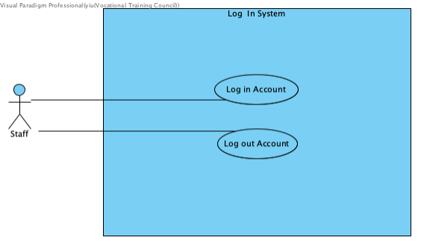

|  |  |
| --- | --- |
| **Use case name:** | Login Account |
| **Use case ID:** | UC-100 |
| **Primary actor:** | Staff |
| **Brief description:** | Staff has provided company email address for logging account. Staff log in account to deal with their works. |
| **Preconditions:** | The staff has entered the page. |
| **Flow of events:** | 1.     The system ask staff to log in.  2.     Staff enter the email address and password in the interface.  3.     Staff see the system function from their department and position due to permission. |
| **Non-behavior requirements:** | If the staff resigned, the user interface will display the message to tell user that the email address is invalid. |

|  |  |
| --- | --- |
| **Use case name:** | Log Out Account |
| **Use case ID:** | UC-101 |
| **Primary actor:** | Staff |
| **Brief description:** | Staff has to log out account after working |
| **Preconditions:** | The staff has logged in account. |
| **Flow of events:** | 1.     Staff clicks the “log out” button in the user interface.  2.     The interface will display ”Log out successfully!” |
| **Postconditions:** | If staff account is not used for more than 8 hours, the account will be logged out automatically. |

* + 1. **POS System**

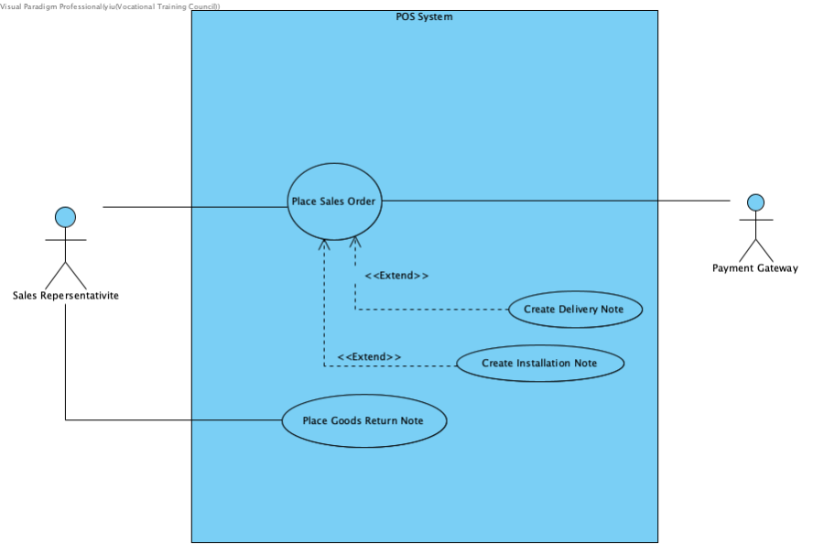

|  |  |
| --- | --- |
| **Use case name:** | Place Sales Order |
| **Use case ID:** | UC-200 |
| **Primary actor:** | Sales Representative |
| **Secondary actor(s):** | Payment Gateway |
| **Brief description:** | The Sales Representative helps customer to place sales order. The Sales Representative and customer check out the goods.  The Sales Representative asks the customer to select the payment method and offers the required information. |
| **Preconditions:** | The Sales Representative has logged in system. |
| **Flow of events:** | 1.     A Sales Representative enters keywords of the goods.  The system displays list of goods matching the keywords.  2.     The Sales Representative selects goods. The system displays the detail information and stock level of goods.  3.     The Sales Representative screens or enters goods ID into the sales order. The system displays goods in the sales order.  4.     The Sales Representative and the customer check out the goods.  5.     The Sales Representative asks the customer whether to select delivery option and install option. If the customer selects the delivery service and installation service, the Sales Representative asks customer to offer personal information to fill the delivery note and installation.  6.     The system displays the total amount.  7.     The Sales Representative asks customer to select the payment method.  8.     The system confirms the transaction and place and print the receipt following sales order.  9.     The system sends the order request to the inventory department and sends receipt to accounting department. It also updates inventory list in retail store. |
| **Postconditions:** | * If the goods is unavailable over $5000, the customer can pay at least 20% of the sold price to make pre-order of goods. After received the goods, the customer pays remaining cost. * If customer doesn’t select delivery and installation service, the Sales Representative does no need to collect the customer information. * A new receipt is created and stored in the sale department system. * The amount is charged to the customer’s credit card, Alipay or WeChat Pay if they choose these payment method. |
| **Alternative flows and exceptions:** | Steps 1-3 can be repeated until the Sales Representative proceeds to step 4.  In step 7, if the customer selects credit card, Alipay or WeChat Pay, the amount is charged to the customer’s credit card through the payment gateway. |
| **Non-behavior requirements:** | The unavailable goods is not over $5000, the pre-order will not be placed. |

|  |  |
| --- | --- |
| **Use case name:** | Create Delivery Note |
| **Use case ID:** | UC-201 |
| **Primary actor:** | Sales Representative |
| **Secondary actor(s):** | The Sales Representative has logged in system. |
| **Brief description:** | The Sales Representative creates Delivery Note when the customer request delivery services. |
| **Preconditions:** | The user has entered the page. |
| **Flow of events:** | 1.     The Sales Representative selects delivery Note in the user interface.  2.     The system displays a page of delivery note that the page includes form for Sales Representative to fill  3.     The Sales Representative fills the form using customer information.  4.     The completed delivery note is sent to inventory department. |
| **Postconditions:** | The delivery note is included by sales order. |

|  |  |
| --- | --- |
| **Use case name:** | Create Installation Note |
| **Use case ID:** | UC-202 |
| **Primary actor:** | Sales Representative |
| **Secondary actor(s):** | The Sales Representative has logged in system. |
| **Brief description:** | The Sales Representative creates Installation Note when the customer requests installation services. |
| **Preconditions:** | The user has entered the page. |
| **Flow of events:** | 1.     The Sales Representative selects installation Note in the user interface.  2.     The system displays a page of installation note that the page includes form for Sales Representative to fill  3.     The Sales Representative fills the form using customer information.  4.     The completed installation note is sent to technical support department. |
| **Postconditions:** | The installation note is included by sales order. |

|  |  |
| --- | --- |
| **Use case name:** | Place Goods Return Note |
| **Use case ID:** | UC-203 |
| **Primary actor:** | Sales Representative |
| **Secondary actor(s):** | The Sales Representative has logged in system. |
| **Brief description:** | The Sales Representative places Goods Return Note for customer when the sold goods have defect. |
| **Preconditions:** | The user has entered the page. |
| **Flow of events:** | 1.     The Sales Representative searchs the receipt record  2.     The system displays a list of receipt and detail of receipt that matches the customer’s paper  or electronic receipt.  3.     The Sales Representative places goods return note including filling the customer and goods information, description of defect goods.  4.     The complete goods return note can be checked inventory department and accounting department.  5.     The defect goods from customers are returned to inventory department. |
| **Non-behavior requirements:** | If the customer loses their receipt, Sales Representative cannot place the Goods Return Note |

* + 1. **System For Sales Department**

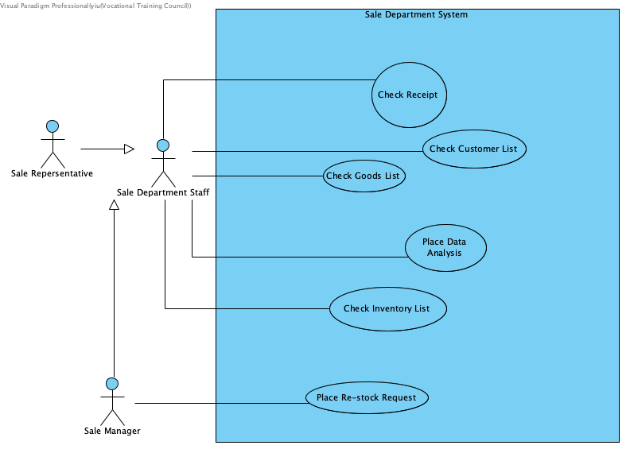

|  |  |
| --- | --- |
| **Use case name:** | Check Receipt |
| **Use case ID:** | UC-300 |
| **Primary actor:** | Sale Department Staff |
| **Brief description:** | Staff store receipt detail in the system and check it when they need. |
| **Preconditions:** | Staff has logged in system. |
| **Flow of events:** | 1.     Staff click the “Receipt” button in the user interface.  2.     They can enter the keywords of goods such as receipt search the receipt.  3.     The interface will display detail of receipt.  4.     There are “Update” button for staff to use. |
| **Non-behavior requirements:** | The data of receipt is not existing in the system, so the staff cannot check or update it. |

|  |  |
| --- | --- |
| **Use case name:** | Check Customer List |
| **Use case ID:** | UC-301 |
| **Primary actor:** | Sale Department Staff |
| **Brief description:** | Staff check customer list. |
| **Preconditions:** | Staff has logged in system. |
| **Flow of events:** | 1.     Sales Representative selects customer list in the user interface.  2.     They can enter the keywords of customer such as customer name to search the information of customer.  3.     The system can display the list of customer for staff to search  4.     When staff select the customer, the system displays the detail. |
| **Non-behavior requirements:** | The data of customer is not existing in the system, so the staff cannot search it and the system display message” Cannot find detail”. |

|  |  |
| --- | --- |
| **Use case name:** | Check Goods List |
| **Use case ID:** | UC-302 |
| **Primary actor:** | Sale Department Staff |
| **Brief description:** | Staff check goods list. |
| **Preconditions:** | Staff has logged in system. |
| **Flow of events:** | 1.     Sales Representative selects goods list in the user interface.  2.     They can enter the keywords of goods such as goods name and to search the information of goods.  3.     The system can display the list of goods for staff to search  4.     When staff select the goods, the system display the detail. |
| **Non-behavior requirements:** | The data of goods is not existing in the system, so the staff cannot search it and the system display message ”Cannot find detail”. |

|  |  |
| --- | --- |
| **Use case name:** | Check Inventory List |
| **Use case ID:** | UC-303 |
| **Primary actor:** | Sale Department Staff |
| **Brief description:** | Staff check inventory list, which is convenient for placing sales order. The inventory list shows stock level including warehouse and two retail stores. |
| **Preconditions:** | Staff has logged in system. |
| **Flow of events:** | 1.     Staff select inventory list in the user interface.  2.     They can enter the keywords of goods such as goods name and goods ID to search the stock level.  3.     The system can display the list of the stock level fromwarehouse and two retail stores for staff to search  4.     When staff select the goods, the system display the detail.  5.     Staff also update stock level after they sold the goods. |
| **Postconditions:** | When the retail store is out of stock level, the system will send the notification to remind Sales Manager to place re-stock request. |
| **Non-behavior requirements:** | The data of goods is not existing in the system, so the staff cannot search it and the system display message ”Cannot find detail”. |

|  |  |
| --- | --- |
| **Use case name:** | Place Re-stock Request |
| **Use case ID:** | UC-304 |
| **Primary actor:** | Sales Manager |
| **Brief description:** | Sales Manager place re-stock request when they receive the system notification in the message box. |
| **Preconditions:** | Staff has logged in system. |
| **Flow of events:** | 1.     Sales Manager selects re-stock request.  2.     The system display re-stock request form.  3.     Manager fills the form and send it to inventory department. |

|  |  |
| --- | --- |
| **Use case name:** | Place Data Analysis |
| **Use case ID:** | UC-305 |
| **Primary actor:** | Sale Department Staff |
| **Brief description:** | Staff has to log out account after working |
| **Preconditions:** | Staff has logged in system. |
| **Flow of events:** | 1.     Staff select Data Analysis  2.     The system displays past few months Data Analysis and “Update” button.  3.     The staff update new data analysis or select other months’ data analysis.  4.     The system shows new data analysis in the list and display detail of data analysis. |

* + 1. **System For Inventory Department**

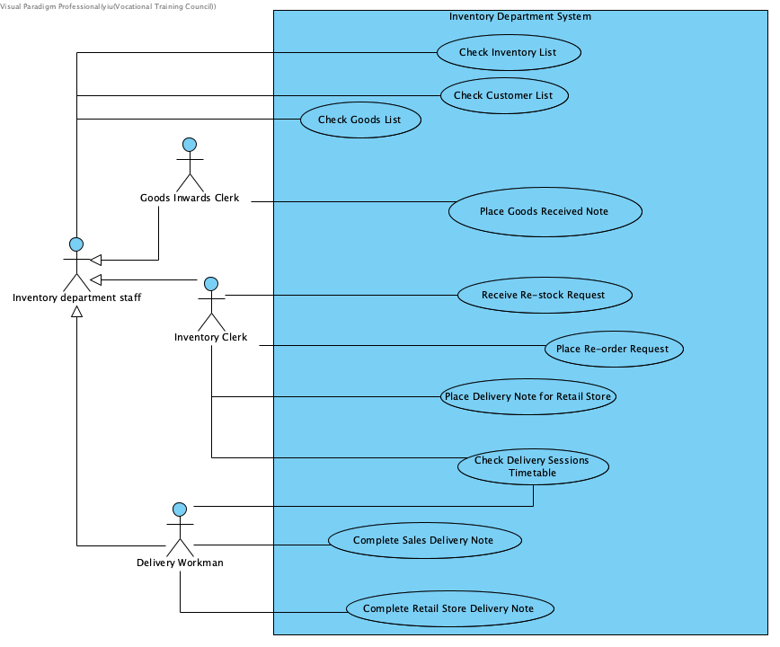

|  |  |
| --- | --- |
| **Use case name:** | Check Inventory List |
| **Use case ID:** | UC-400 |
| **Primary actor:** | Inventory Department Staff |
| **Brief description:** | Inventory Department Staff check and update the Inventory List after restocking and delivery. |
| **Preconditions:** | The staff has logged in account. |
| **Flow of events:** | 1.     Staff select inventory list in the user interface.  2.     They can enter the keywords of goods such as goods name and goods ID to search the stock level.  3.     The system display the list of the stock level from warehouse and two retail stores for staff to search  4.     When staff select the goods, the system display the detail.  5.     Staff also update stock level after restocking and delivery. |

|  |  |
| --- | --- |
| **Use case name:** | Check Customer List |
| **Use case ID:** | UC-401 |
| **Primary actor:** | Inventory Department Staff |
| **Brief description:** | Staff check customer list. |
| **Preconditions:** | Staff has logged in system. |
| **Flow of events:** | 1.     Staff selects customer list in the user interface.  2.     They can enter the keywords of customer such as and customer name to search the information of customer.  3.     The system display the list of customers for staff to search  4.     When staff select the customer, the system displays the detail. |
| **Non-behavior requirements:** | The data of customer is not existing in the system, so the staff cannot search it and the system display message ”Cannot find detail”. |

|  |  |
| --- | --- |
| **Use case name:** | Check Goods List |
| **Use case ID:** | UC-402 |
| **Primary actor:** | Inventory Department Staff |
| **Brief description:** | Staff check goods list. |
| **Preconditions:** | Staff has logged in system. |
| **Flow of events:** | 1.     Staff select goods list in the user interface.  2.     They can enter the keywords of goods such as goods name to search the information of goods or customer.  3.     The system displays the list of goods for staff to search  4.     When staff select the goods, the system display the detail. |
| **Non-behavior requirements:** | The data of goods is not existing in the system, so the staff cannot search it and the system display message” Cannot find detail”. |

|  |  |
| --- | --- |
| **Use case name:** | Place Goods Received Note |
| **Use case ID:** | UC-403 |
| **Primary actor:** | Goods Inwards Clerk |
| **Brief description:** | Goods inwards clerk place goods received note after they check the restock goods correct. |
| **Preconditions:** | Staff has logged in system. |
| **Flow of events:** | 1.     The clerk selects Goods Received Note in the user interface.  2.     They can use bar-code scanner to scan the goods bar-code to certain that the quantity of goods from purchase order and delivery note from supplier is the same.  3.     They place a new goods received note to record restocking data.  4.     The system store the note. |
| **Postconditions:** | They receive notification about purchase order in the message box. |

|  |  |
| --- | --- |
| **Use case name:** | Receive Re-stock Request |
| **Use case ID:** | UC-404 |
| **Primary actor:** | Inventory Clerk |
| **Brief description:** | Inventory Clerk receive and check re-stock request. |
| **Preconditions:** | Staff has logged in system. |
| **Flow of events:** | 1.     The clerk receives the notification about re-stock request in the message box.  2.     They select re-stock request or notification in the user interface.  3.     The system display the detail of request.  4.     The clerk place a delivery note for retail store. |

|  |  |
| --- | --- |
| **Use case name:** | Place Re-order Request |
| **Use case ID:** | UC-405 |
| **Primary actor:** | Inventory Clerk |
| **Brief description:** | Inventory Clerk places re-order request when warehouse is out of stock level. |
| **Preconditions:** | Staff has logged in system. |
| **Flow of events:** | 1.     The clerk selects re-order request in the UI and kick “Form”.  2.     The system displays the form for clerk to fill.  3.     The clerk fills the form and send it to purchasing department. |

|  |  |
| --- | --- |
| **Use case name:** | Check Delivery Sessions Timetable |
| **Use case ID:** | UC-406 |
| **Primary actor:** | Inventory Clerk and Delivery Workman |
| **Brief description:** | Inventory Clerk checks Delivery Sessions Timetable and arrange the delivery time. Delivery Workman checks timetable to deliver goods. |
| **Preconditions:** | Staff has logged in system. |
| **Flow of events:** | 1.     Clerk and delivery workman select Delivery Sessions Timetable in the UI.  2.     The system displays timetable.  3.     Clerk modifies timetable following the delivery note.  4.     The system updates the newest timetable. |
| **Non-behavior requirements:** | If the goods is exceed 5 quantity in one session, the system does not allow clerk to add delivery in that session. |

|  |  |
| --- | --- |
| **Use case name:** | Place Delivery Note for Retail Store |
| **Use case ID:** | UC-407 |
| **Primary actor:** | Inventory Clerk |
| **Brief description:** | According to re-order request, Inventory Clerk places Delivery Note for retail store. |
| **Preconditions:** | Staff has logged in system. |
| **Flow of events:** | 1.     Clerk selects Delivery Note (Retail Store) in the UI.  2.     The system displays list of delivery note and “Form” button.  3.     Clerk clicks the “Form” button and fill form.  4.     The delivery note is sent to list of Retail Store Delivery Note by the system. |

|  |  |
| --- | --- |
| **Use case name:** | Complete Sales Delivery Note |
| **Use case ID:** | UC-408 |
| **Primary actor:** | Delivery Workman |
| **Brief description:** | Delivery Workman completes Sales Delivery Note after delivery is successful for customer. |
| **Preconditions:** | Staff has logged in system and use tablet |
| **Flow of events:** | 1.     Workman selects Sales Delivery Note in UI.  2.     The system displays list of delivery note  3.     They selects the specify delivery note.  4.     The system displays detail of delivery note.  5.     Workman gives the tablet for customer to sign.  6.     After delivery, workman clicks “Complete” Button for specify delivery note. |
| **Non-behavior requirements:** | Without customer signature, the delivery note cannot be completed. |

|  |  |
| --- | --- |
| **Use case name:** | Complete Retail Store Delivery Note |
| **Use case ID:** | UC-409 |
| **Primary actor:** | Delivery Workman |
| **Brief description:** | Delivery Workman completes Delivery Note after delivery is successful for retail stores. |
| **Preconditions:** | Staff has logged in system and use tablet |
| **Flow of events:** | 1.     Workman selects Retail Store Delivery Note in UI.  2.     The system display list of delivery note  3.     Workman selects the specify delivery note.  4.     The system displays detail of delivery note.  5.     Workman gives the tablet for Retail Store-Sales Manager to sign.  6.     After delivery, workman clicks “Finish” Button for specify delivery note. |
| **Non-behavior requirements:** | Without Sales Manager signature, the delivery note cannot be completed. |

* + 1. **System For Technical Support Department**

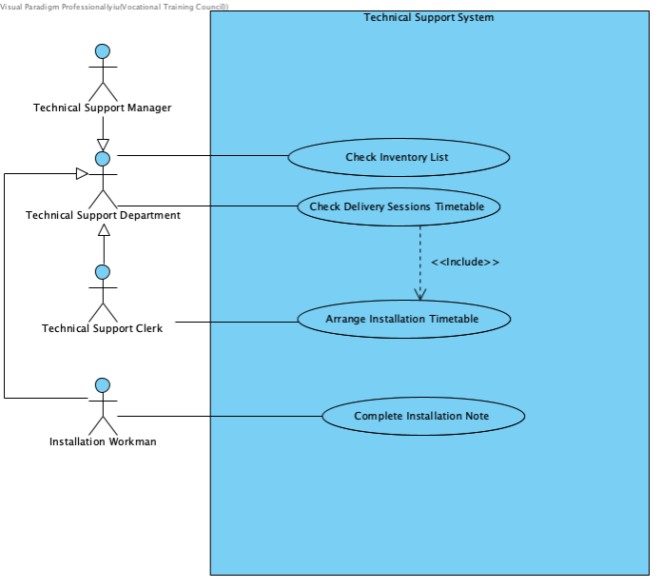

|  |  |
| --- | --- |
| **Use case name:** | Check Inventory List |
| **Use case ID:** | UC-500 |
| **Primary actor:** | Technical Support Department Staff |
| **Brief description:** | Technical Support Staff checks the Inventory List. |
| **Preconditions:** | The staff has logged in account. |
| **Flow of events:** | 1.     Staff selects inventory list in the user interface.  2.     They can enter the keywords of goods such as goods name and goods ID to search the stock level.  3.     The system displays the list of the stock level from warehouse and two retail stores for staff to search  4.     When staff select the goods, the system display the detail. |
| **Non-behavior requirements:** | The data of goods is not existing in the system, so the staff cannot search it and the system display message ”Cannot find details”. |

|  |  |
| --- | --- |
| **Use case name:** | Check Delivery Sessions Timetable |
| **Use case ID:** | UC-501 |
| **Primary actor:** | Technical Support Department Staff |
| **Brief description:** | Staff check Delivery Sessions Timetable to arrange installation. |
| **Preconditions:** | Staff has logged in system. |
| **Flow of events:** | 1.     Staff select Delivery Sessions Timetable in the UI.  2.     The system displays timetable. |

|  |  |
| --- | --- |
| **Use case name:** | Arrange Installation Timetable |
| **Use case ID:** | UC-502 |
| **Primary actor:** | Technical Support Clerk |
| **Brief description:** | Technical Support Clerk arrange Installation Timetable after checking Delivery Sessions Timetable. |
| **Preconditions:** | Staff has logged in system. |
| **Flow of events:** | 1.     Clerk selects  nstallation Timetable in the UI.  2.     The system display sInstallation Timetable.  3.     Clerk arranges timetable following the Delivery Sessions Timetable. |
| **Non-behavior requirements:** | The installation time must be arranged after more than delivery time 2 hours. Otherwise, the installation timetable cannot be modified successfully. |

|  |  |
| --- | --- |
| **Use case name:** | Complete Installation Note |
| **Use case ID:** | UC-503 |
| **Primary actor:** | Installation Workman |
| **Brief description:** | Delivery Workman completes Delivery Note after delivery is successful for retail stores. |
| **Preconditions:** | Staff has logged in system and use tablet |
| **Flow of events:** | 1.     Workman selects Retail Store Delivery Note in UI.  2.     The system displays list of delivery note  3.     Workman selects the specify delivery note.  4.     The system display detail of delivery note.  5.     Workman gives the tablet for Retail Store-Sales Manager to sign.  6.     After delivery, workman clicks “Finish” Button for specify delivery note. |

* + 1. **System For Purchasing Department**

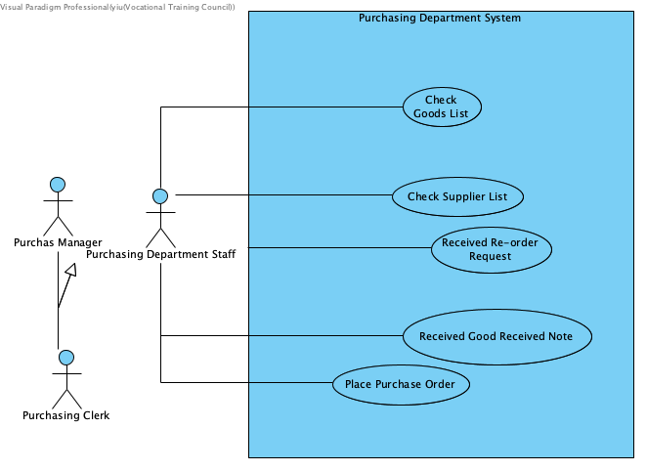

| **Use case name:** | Check Goods List and Supplier List |
| --- | --- |
| **Use case ID:** | UC-600 |
| **Primary actor:** | Purchasing Department Staff |
| **Brief description:** | Purchasing Department Staff check Goods List and Supplier List |
| **Preconditions:** | Staff has logged in system and use tablet |
| **Flow of events:** | 1.     Staff select Goods List and Supplier List in UI.  2.     The system displays list of goods or and supplier.  3.     Staff enter the keywords of goods such as goods name and supplier name to search the information of goods or customer.  4.     The system displays the list of goods or supplier for staff to search.  5.     When staff select the goods or supplier, the system display the detail. |
| **Non-behavior requirements:** | The data of customer or goods is not existing in the system, so the staff cannot search it and the system display message” Cannot find detail”. |

|  |  |
| --- | --- |
| **Use case name:** | Receive Re-order Request |
| **Use case ID:** | UC-601 |
| **Primary actor:** | Purchasing Department Staff |
| **Brief description:** | Purchasing Department Staff receive and check re-order request. |
| **Preconditions:** | Staff has logged in system. |
| **Flow of events:** | 1.     Staff receive the notification about re-order request in the message box.  2.     They select re-order request or notification in the user interface.  3.     The system displays the detail of request. |

|  |  |
| --- | --- |
| **Use case name:** | Receive Goods Received Note |
| **Use case ID:** | UC-602 |
| **Primary actor:** | Purchasing Department Staff |
| **Brief description:** | Purchasing Department Staff receives goods received note. |
| **Preconditions:** | Staff has logged in system. |
| **Flow of events:** | 1.     Staff receives the notification about goods received note in the message box.  2.     They select goods received note or notification in the user interface.  3.     The system displays the detail of request. |

|  |  |
| --- | --- |
| **Use case name:** | Place Purchase Order |
| **Use case ID:** | UC-603 |
| **Primary actor:** | Purchasing Department Staff |
| **Brief description:** | Purchasing Department Staff places purchase order following re-order request. |
| **Preconditions:** | Staff has logged in system. |
| **Flow of events:** | 1.     Clerk selects Purchase Order in the UI.  2.     The system displays Purchase Order and “Form” button.  3.     Clerk clicks the “Form” button and fill form.  4.     The Purchase Order is sent to Accounting Department by the system. |

* + 1. **System For Accounting Department**

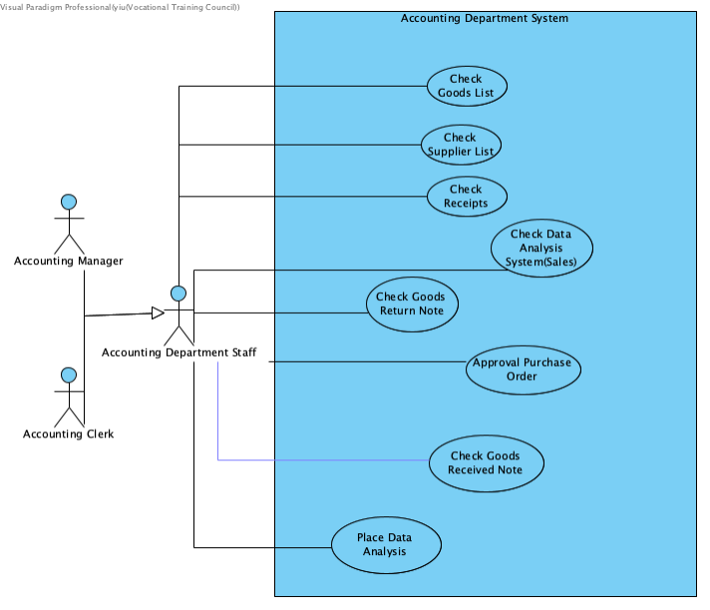

|  |  |
| --- | --- |
| **Use case name:** | Check Goods List , Supplier List, Receipts and Data Analysis (Sales) |
| **Use case ID:** | UC-800 |
| **Primary actor:** | Accounting Department Staff |
| **Brief description:** | Purchasing Department Staff checks Goods List and Supplier List |
| **Preconditions:** | Staff has logged in system and use tablet |
| **Flow of events:** | 1.     Staff select Goods List, Supplier List, Receipts or Data Analysis (Sales) in UI.  2.     The system displays page of Goods List, Supplier List, Receipts or Data Analysis (Sales).  3.     Staff enter the keywords to search the information.  4.     The system displays the list for staff to search.  5.     When staff click the item, the system display the detail. |
| **Non-behavior requirements:** | The data is not existing in the system, so the staff cannot search it and the system display message” Cannot find detail”. |

|  |  |
| --- | --- |
| **Use case name:** | Check Goods Return Note and Goods Received Note. |
| **Use case ID:** | UC-800 |
| **Primary actor:** | Accounting Department Staff |
| **Brief description:** | Purchasing Department Staff check Goods Return Note and Goods Received Note. These notes have notification function to remind them to check it. |
| **Preconditions:** | Staff has logged in system and use tablet |
| **Flow of events:** | 1.     Staff receive the notification about goods received note in the message box.  2.     Staff select message, Goods Return Note or Goods Received Note in UI.  3.     The system displays page of Goods Return Note and Goods Received Note.  4.     Staff can enter the keywords such as ID to search the information.  5.     The system displays the list for staff to search.  6.     When staff click the specify note, the system display the detail. |
| **Non-behavior requirements:** | The data is not existing in the system, so the staff cannot search it and the system display message” Cannot find detail”. |

|  |  |
| --- | --- |
| **Use case name:** | Approval Purchase Order |
| **Use case ID:** | UC-801 |
| **Primary actor:** | Accounting Department Staff |
| **Brief description:** | Accounting Department Staff receive purchase order in the Notification and check the purchase order. They approval or overrule the purchase order |
| **Preconditions:** | Staff has logged in system. |
| **Flow of events:** | 1.     Staff receive the notification about purchase order in the message box.  2.     They select purchase order or notification in the user interface.  3.     The system displays the detail of purchase order.  4.     Staff select “Approval” or “Overrule” button to approval or overrule the purchase order.  5.     The system send back the result to purchase department. |

|  |  |
| --- | --- |
| **Use case name:** | Place Data Analysis |
| **Use case ID:** | UC-802 |
| **Primary actor:** | Accounting Department Staff |
| **Brief description:** | Staff has to log out account after working |
| **Preconditions:** | Staff has logged in system. |
| **Flow of events:** | 1.     Staff select Data Analysis  2.     The system displays past few months Data Analysis and “Update” button.  3.     The staff update new data analysis or select other months’ data analysis.  4.     The system shows new data analysis in the list and display detail of data analysis. |

* + 1. **Online Store (Web & Mobile App)**

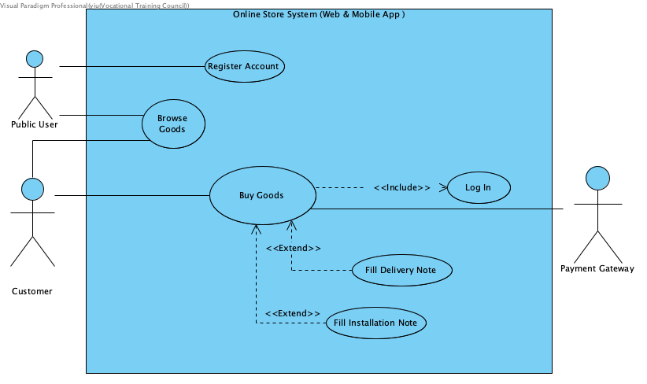

|  |  |
| --- | --- |
| **Use case name:** | Register Account |
| **Use case ID:** | UC-900 |
| **Primary actor:** | Public User |
| **Brief description:** | A public user provides name, phone number, email address, home address, password to register a new customer account. |
| **Preconditions:** | The user is not logged in and the email address has not been used by an existing customer. |
| **Flow of events:** | 1.     The public user enter their name, phone number, email address, the home address and the password.  2.     The system verifies that the address has not been used by an existing user.  3.     The system creates a new account for the customer. |
| **Postconditions:** | An account is created. |
| **Non-behavior requirements:** | If the email address has been used by an existing customer, the user interface will display the message to tell customer that the email address was used. |

|  |  |
| --- | --- |
| **Use case name:** | Browse Goods |
| **Use case ID:** | UC-901 |
| **Primary actor:** | Public User, Customer |
| **Brief description:** | A user can browse goods by entering keywords which may appear in the goods name, band or goods description. |
| **Preconditions:** | The user has entered the page. |
| **Flow of events:** | 1.     The public user or customer enters keywords of the goods.  2.     The system displays a list of goods that matches the keyword.  3.     The public user or customer selects a goods from the list.  4.     The system displays the details of the selected goods. |
| **Alternative flows and exceptions:** | Step 1-4 can be repeated until the customer stops to browse. |
| **Non-behavior requirements:** | The data of goods is not existing in the system, so the user cannot browse it. |

|  |  |
| --- | --- |
| **Use case name:** | Log in |
| **Use case ID:** | UC-902 |
| **Primary actor:** | Customer |
| **Brief description:** | Customer log in the account to use the online shop services. |
| **Preconditions:** | The user has entered email address and password. |
| **Flow of events:** | 1.     Customer selects log in in the user interface.  2.     The system displays page for logging in.  3.     Customer enters email address and password.  4.     They system allows customer using “buy goods” function. |
| **Non-behavior requirements:** | If customer enter a wrong account or wrong password, the system show “please enter valid email address or password.” |

|  |  |
| --- | --- |
| **Use case name:** | Buy Goods |
| **Use case ID:** | UC-903 |
| **Primary actor:** | Customer |
| **Secondary actor(s):** | Payment Gateway |
| **Brief description:** | The customer searches and selects goods.  The customer adds the goods into the shopping cart.  The customer checks out the goods.  The customer selects the payment method and enters the required information.  The system charges the amount to the customer’s credit card account or account. |
| **Preconditions:** | The customer has a valid account. |
| **Flow of events:** | 1.     A customer enters keywords of the goods.  The system displays list of goods matching the keywords.  2.     The customer selects goods. The system displays the detail information of goods.  3.     The customer adds a goods into the shopping cart. The system displays goods in the shopping cart.  4.     The customer checks out the goods.  The system asks the customer to login.  5.     The customer enters the email address and password. The system asks the customer to select delivery option and install option.  6.     The customer selects delivery option and install option, they need to fill the delivery note and installation note.  The system displays the total amount.    7.     The customer selects the payment method and enters the required information.  The system charges the amount to the customer’s credit card account or account.  8.     The system confirms the transaction and place electronic receipt including delivery note and installation note following order.   9.     The system sends the order request to the inventory department and the electronic receipt to customer in email. |
| **Postconditions:** | A new buy order is created and stored in the system. The amount is charged to the customer’s account or credit card. |
| **Alternative flows and exceptions:** | ·      Steps 1-3 can be repeated until the customer proceeds to step 4.  ·      In step 7, if the customer selects credit card payment, the amount is charged to the customer’s credit card through the payment gateway. |
| **Non-behavior requirements:** | If the user has not been registered, the user interface allows the user to choose to register when the user is prompted to login. |

|  |  |
| --- | --- |
| **Use case name:** | Fill Delivery Note |
| **Use case ID:** | UC-904 |
| **Primary actor:** | Sales Representative |
| **Secondary actor(s):** | The Sales Representative has logged in system. |
| **Brief description:** | Customer fills Delivery Note if the customer need delivery services. |
| **Preconditions:** | The user has entered the page. |
| **Flow of events:** | 1.     Customer selects delivery Note in the user interface.  2.     The system displays a page of delivery note that the page includes form for they to fill  3.     Customer fills the form.  4.     The completed delivery note is sent to inventory department. |

|  |  |
| --- | --- |
| **Use case name:** | Fill Installation Note |
| **Use case ID:** | UC-905 |
| **Primary actor:** | Sales Representative |
| **Secondary actor(s):** | The Sales Representative has logged in system. |
| **Brief description:** | Customer fills Installation Note if the customer needs installation services. |
| **Preconditions:** | The user has entered the page. |
| **Flow of events:** | 1.     Customer selects installation y Note in the user interface.  2.     The system displays a page of installation note that the page includes form for they to fill  3.     Customer fills the form.  4.     The completed installation note is sent to inventory department. |

1. Structure Chart

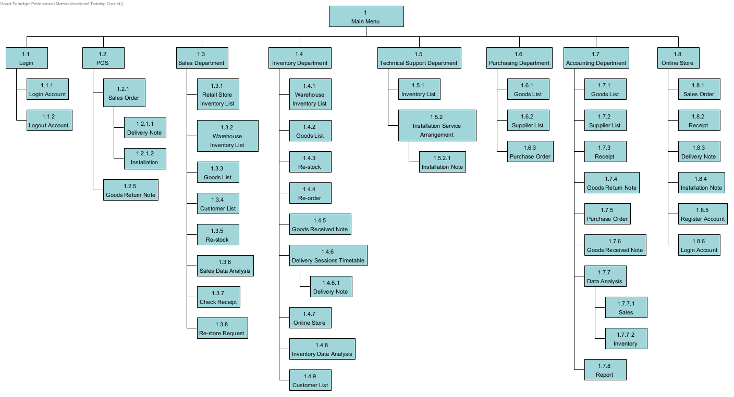

1. Sequence Diagram
   1. Login And Logout

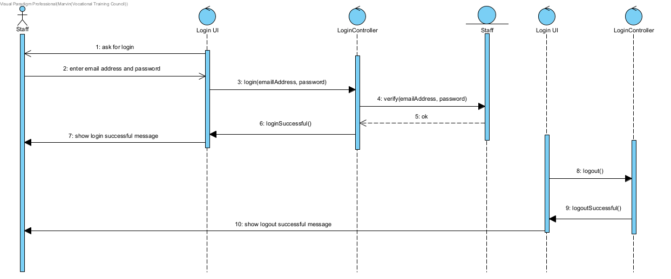

* 1. POS (Credit Card Payment)

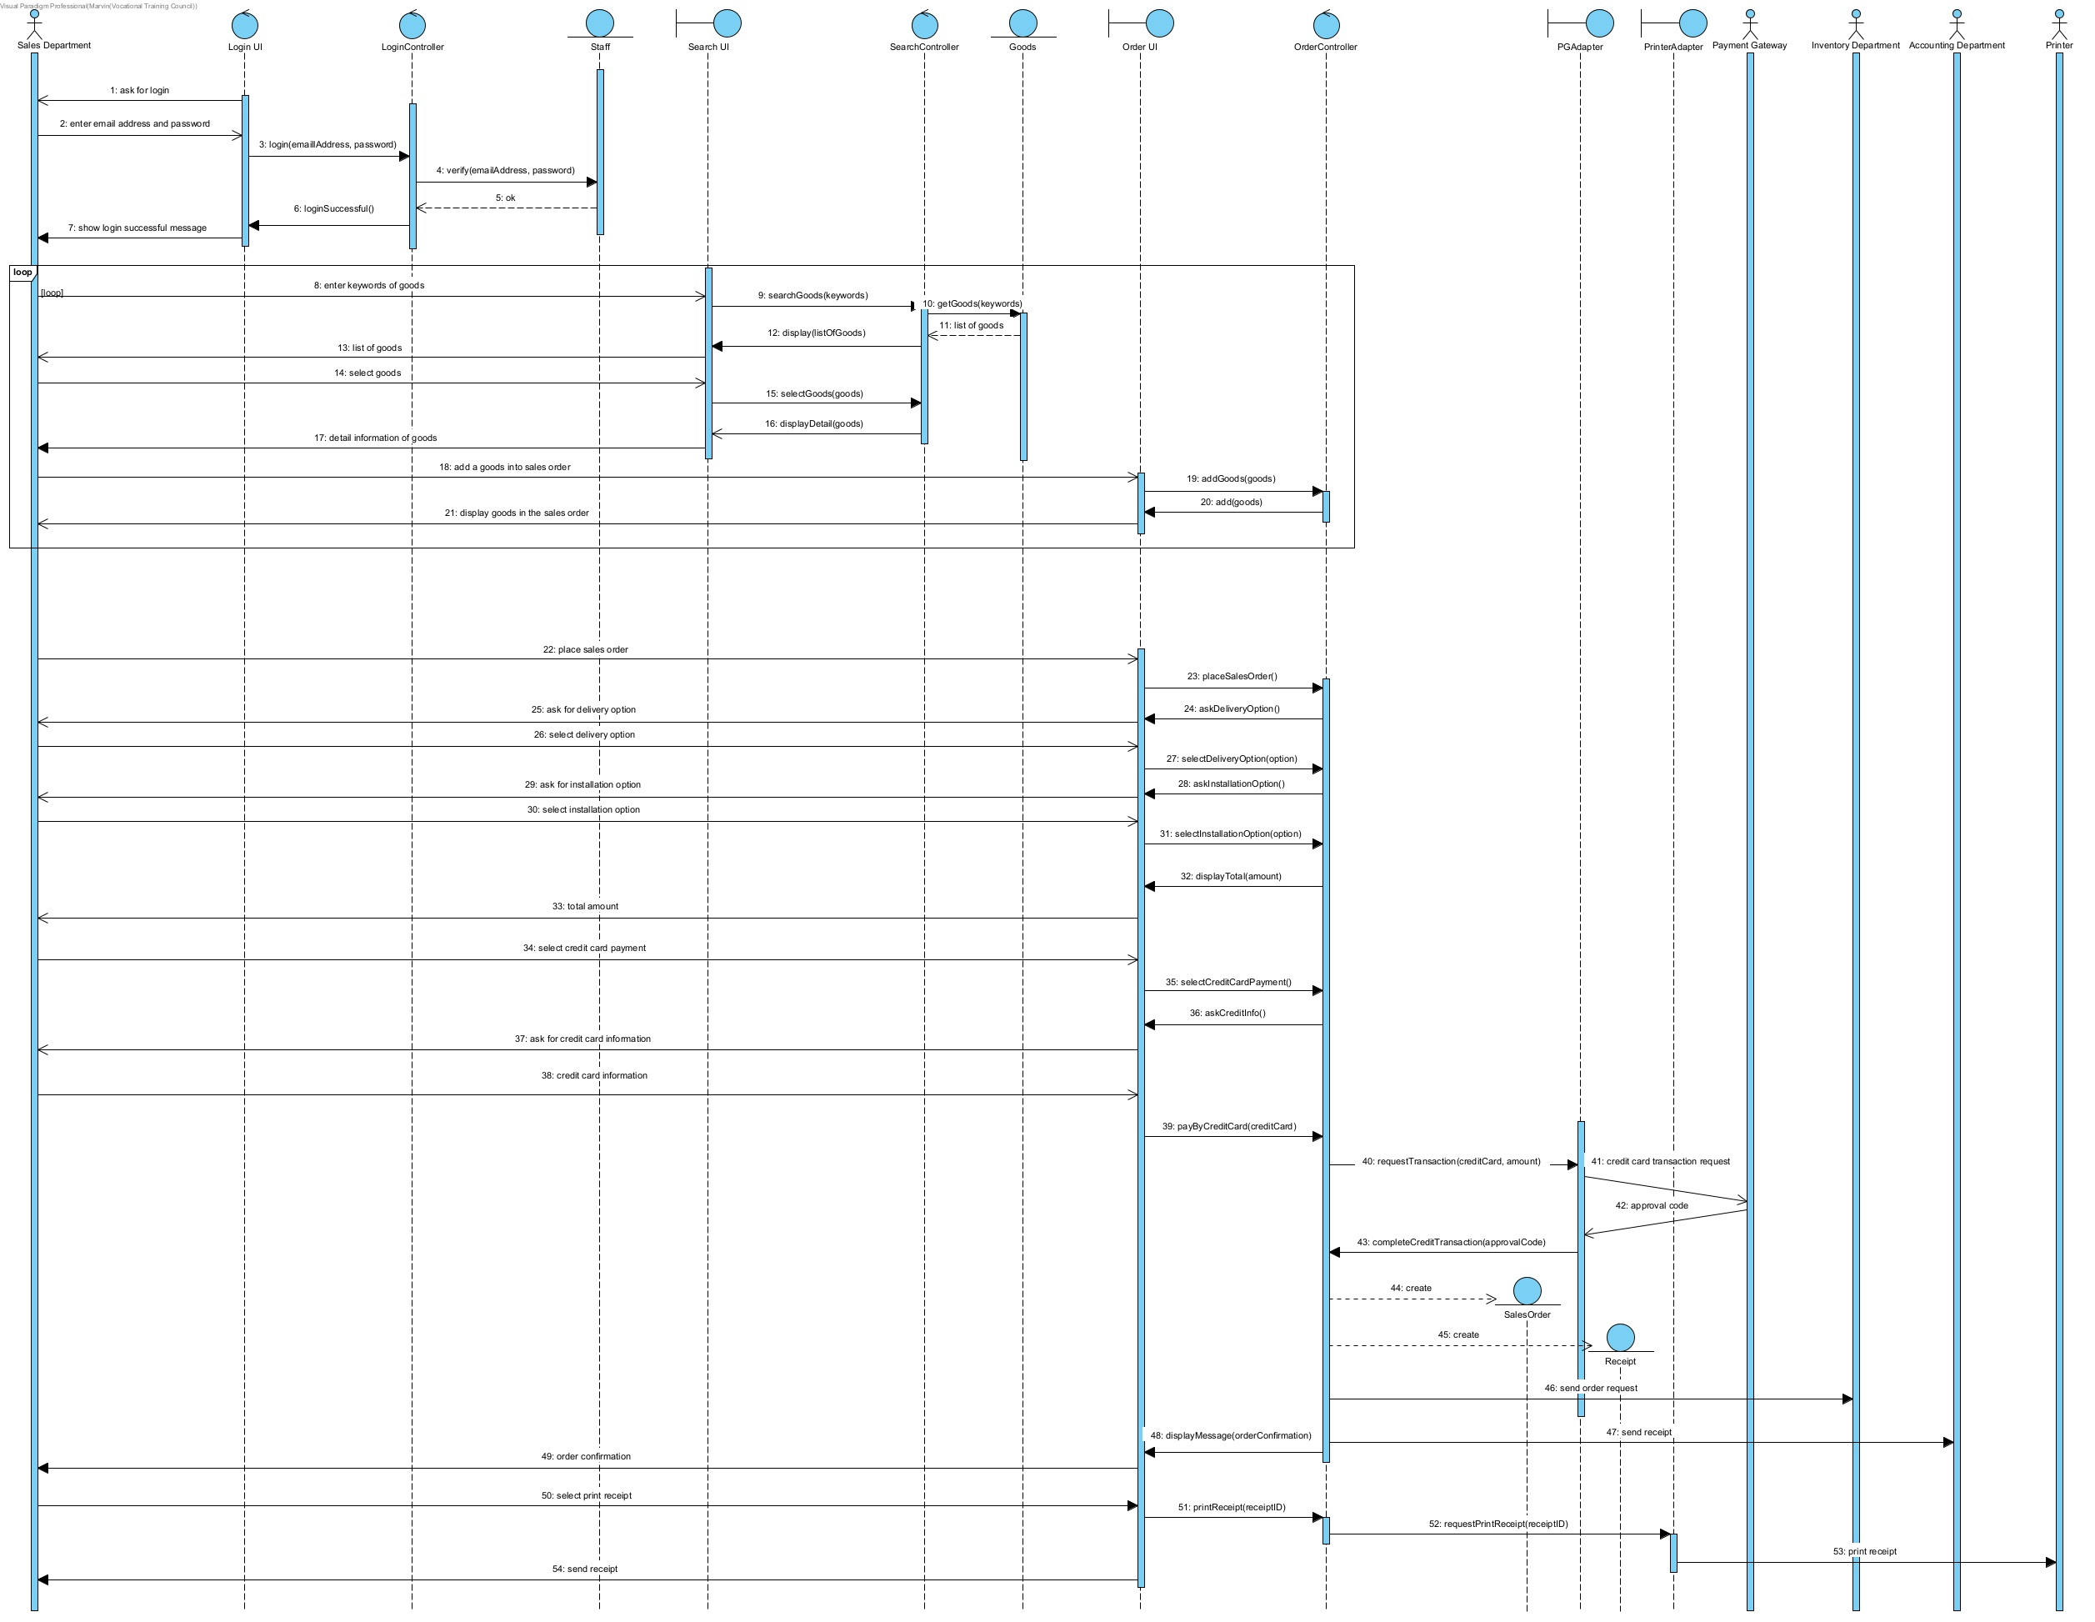

* 1. POS Place Order (Digital Payment)

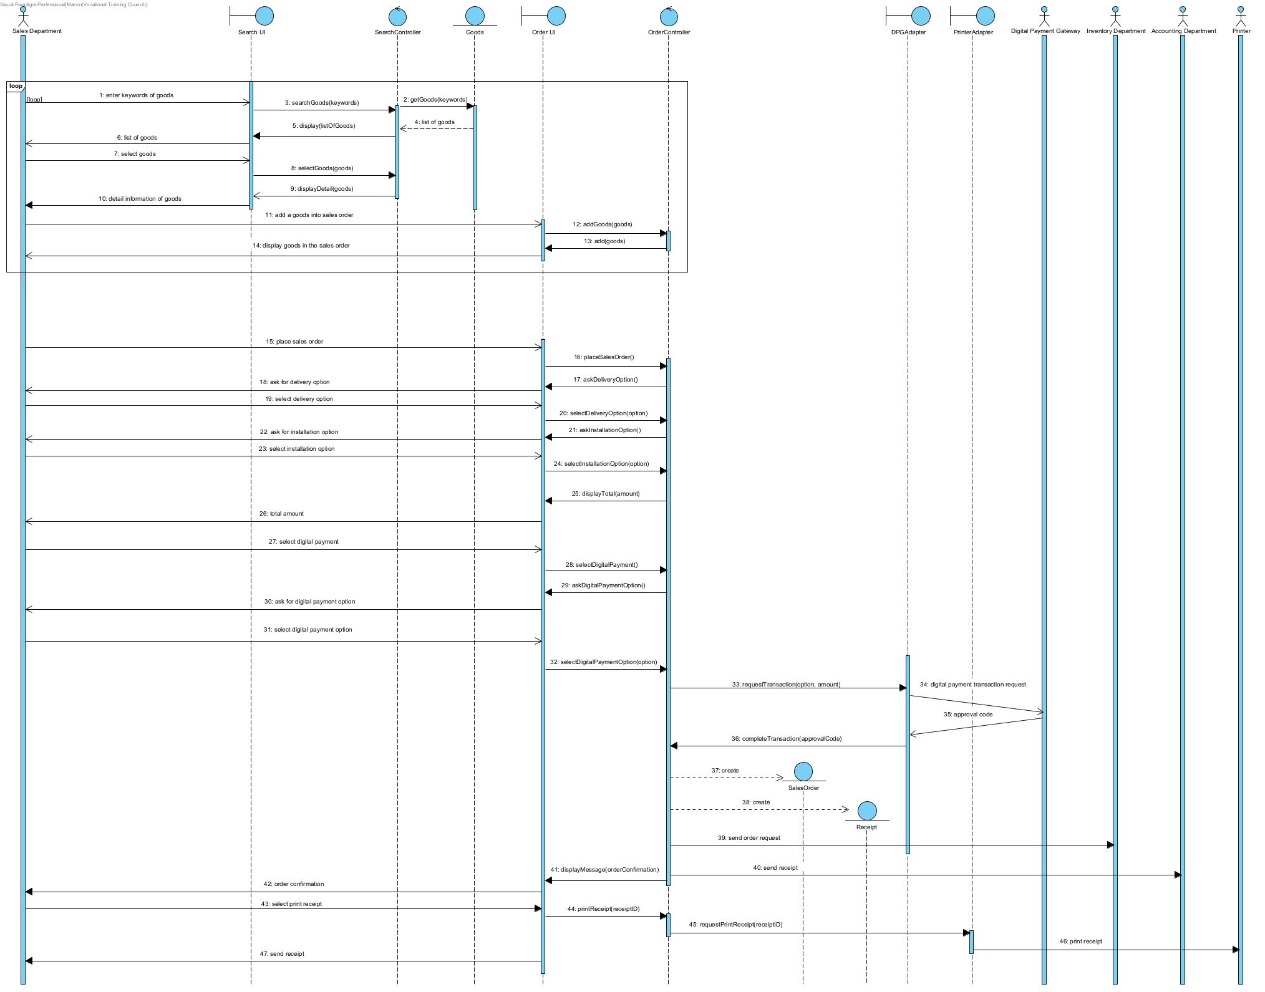

* 1. POS Place Goods Return Note

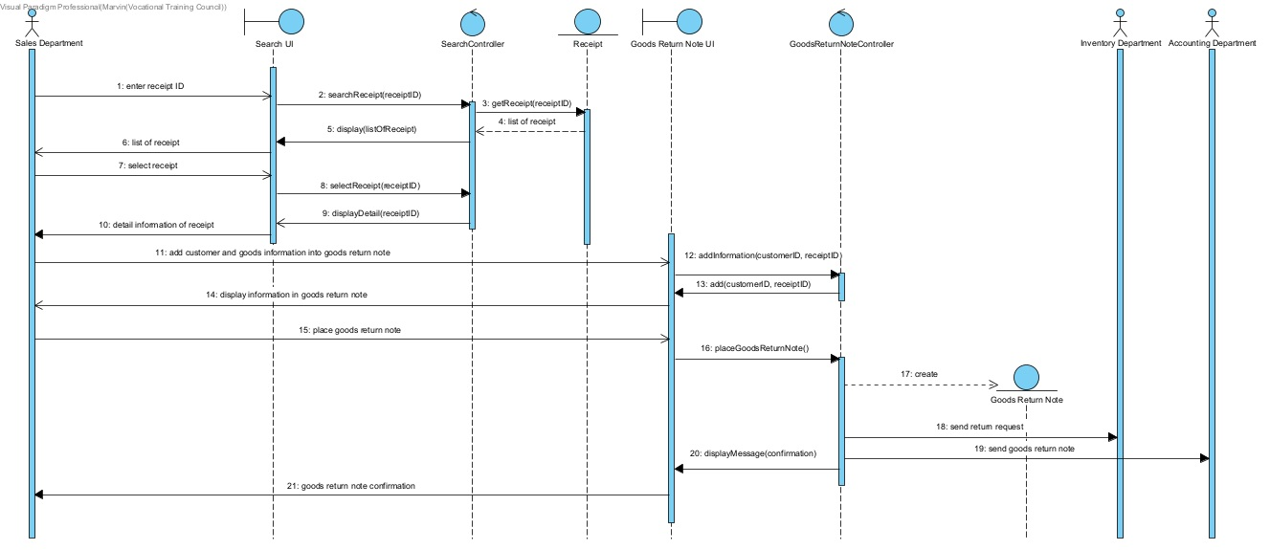

* 1. Checking

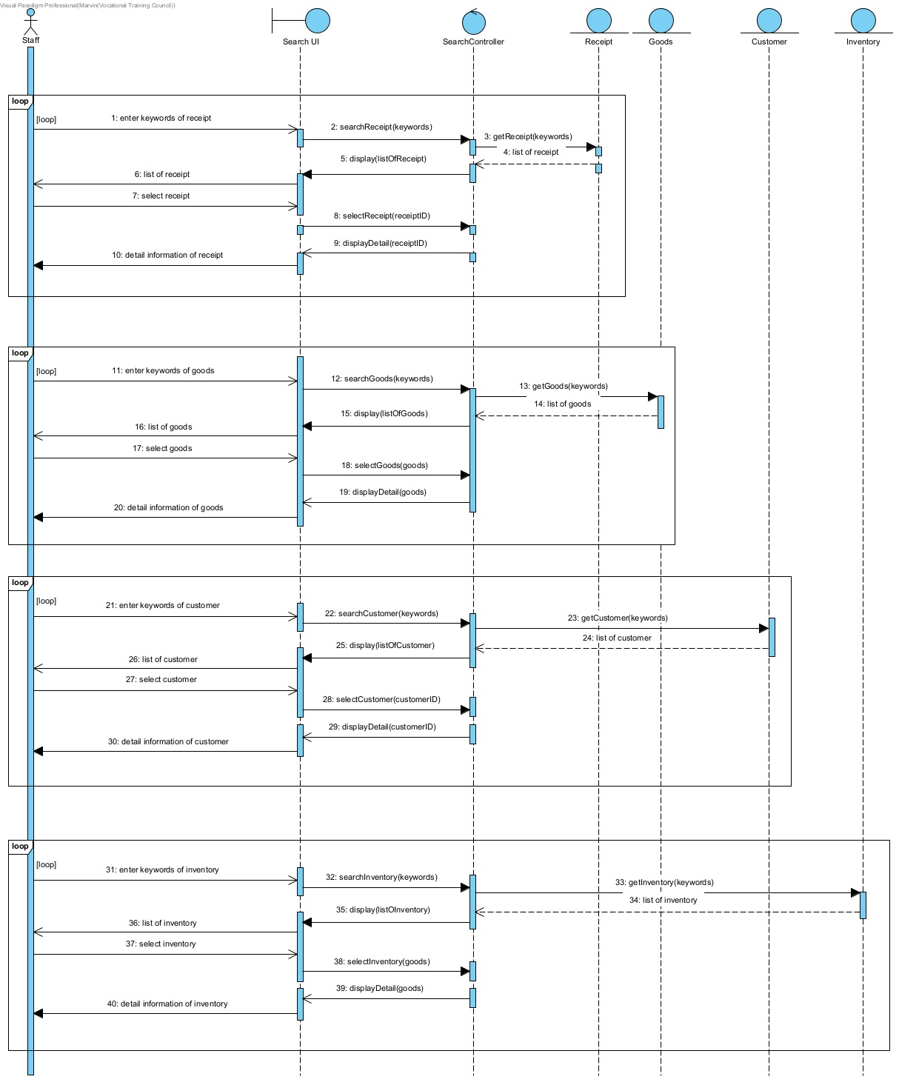

* 1. Re-stock And Re-order Request

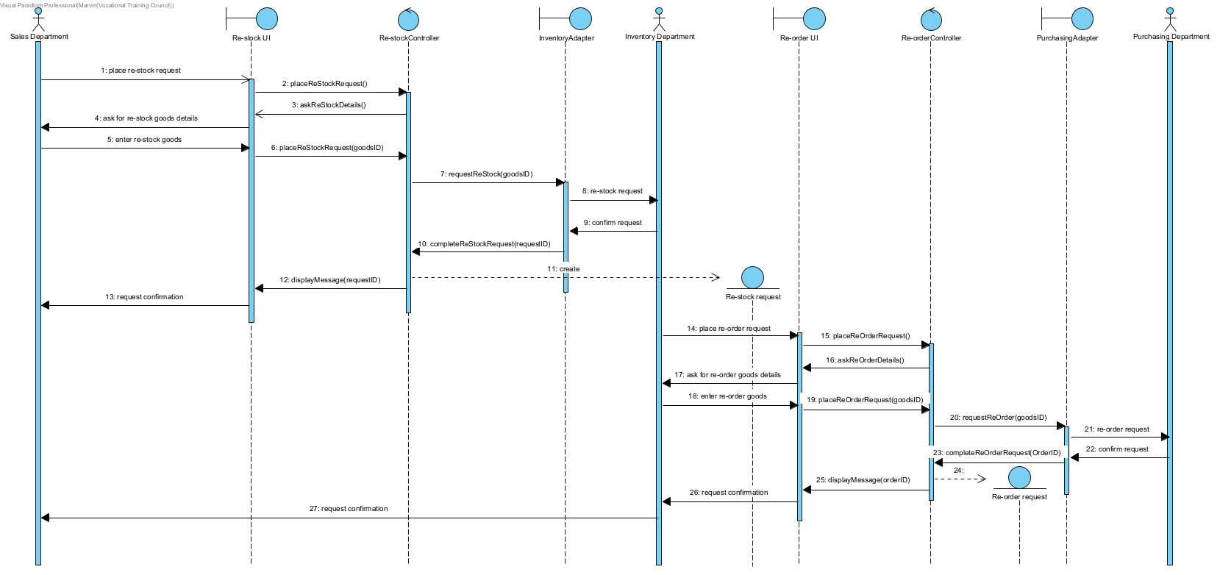

* 1. Place Goods Received Note

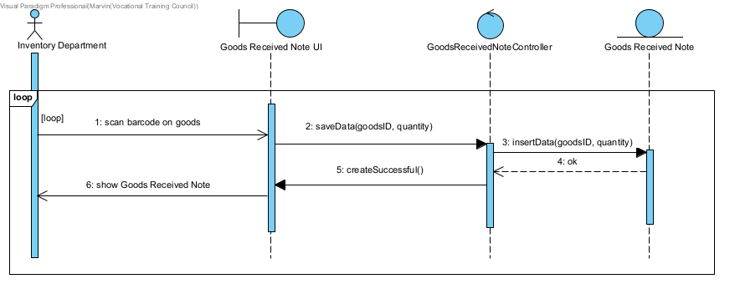

* 1. Delivery And Installation Timetable Arrangement

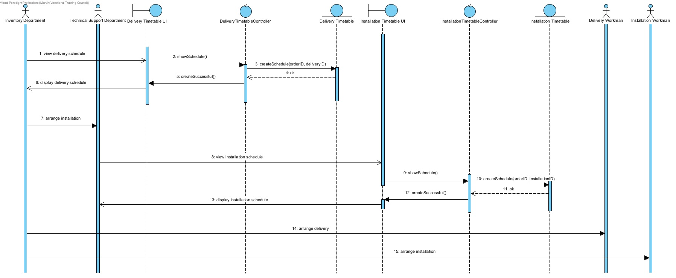

* 1. Place Purchase Order

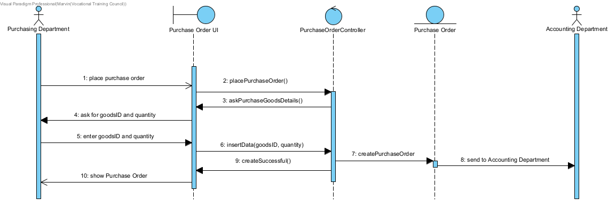

* 1. Data Analysis

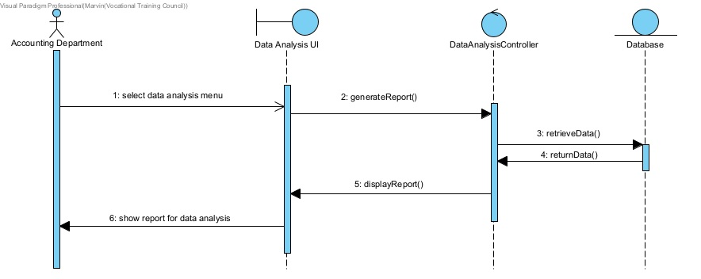

* 1. Register and buy goods with credit card (Online Store)

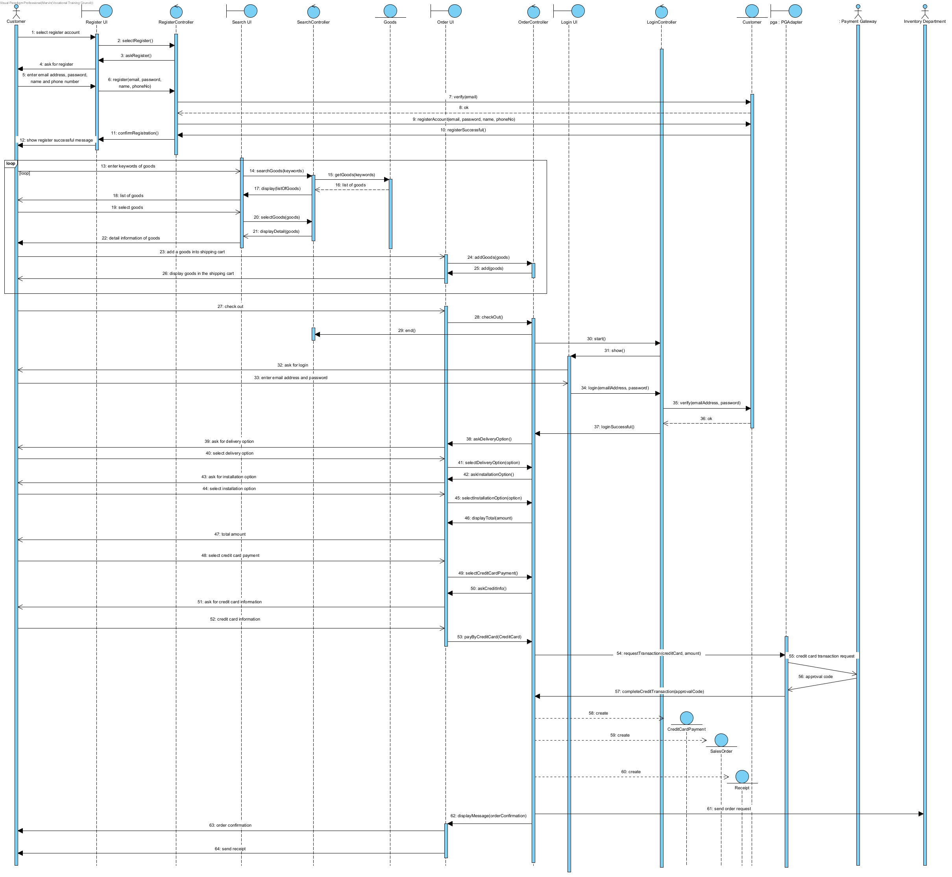

* 1. Register and buy goods with digital payment (Online Store)

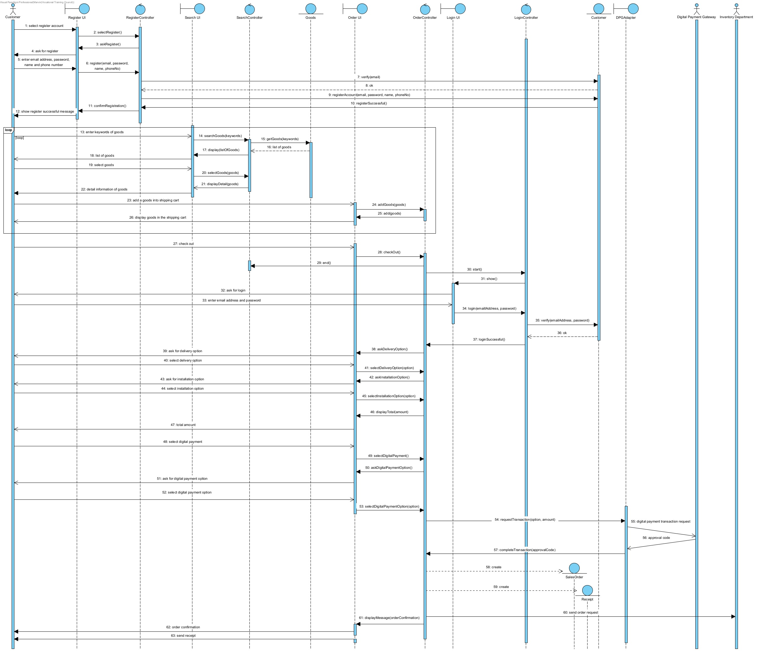

1. UI
   1. System

**🡪**[**Prototype Link**](https://www.figma.com/proto/argZNrXTBtfxw4jTEZi3Kx/Better-Limited?node-id=1%3A67&scaling=min-zoom&page-id=1%3A66&starting-point-node-id=1%3A67)**🡨**

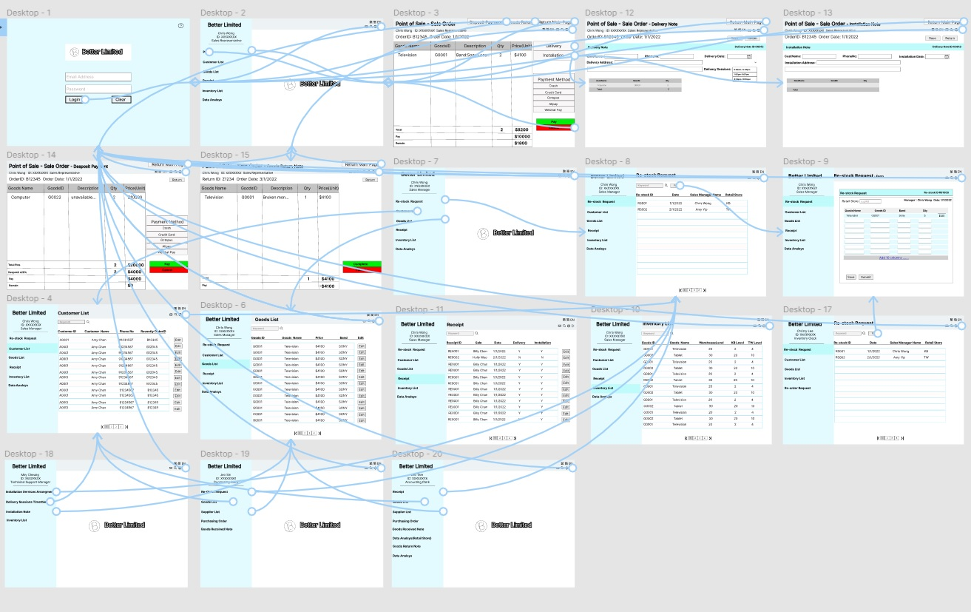

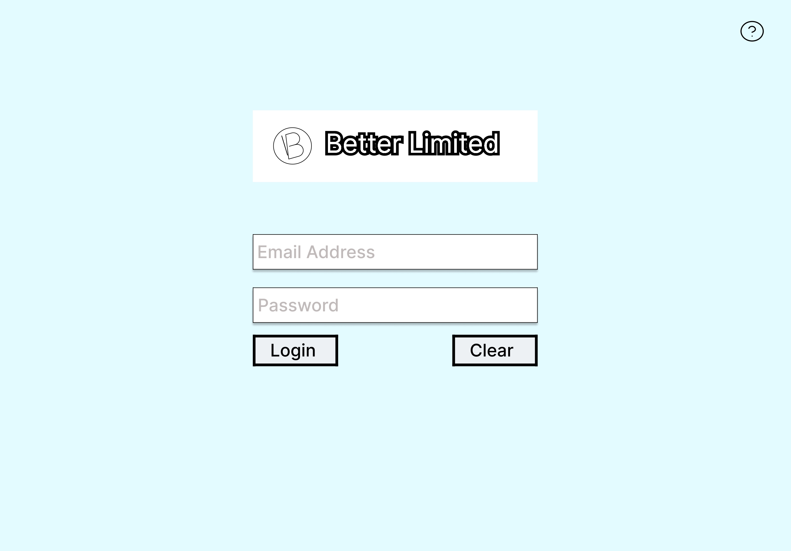

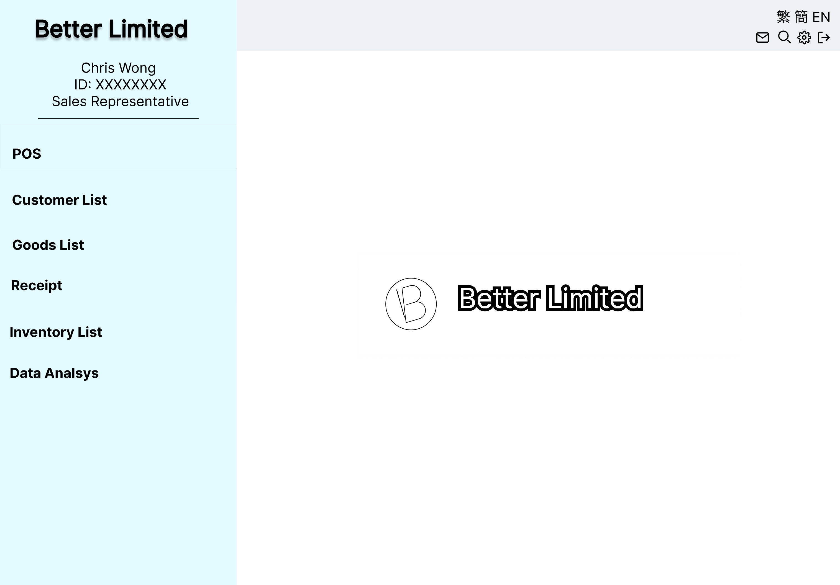

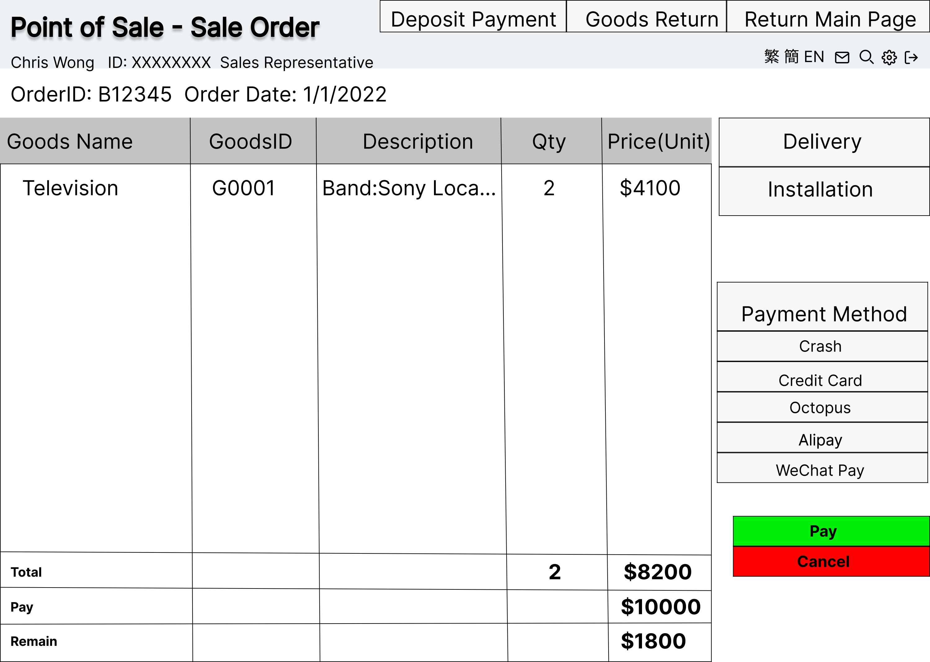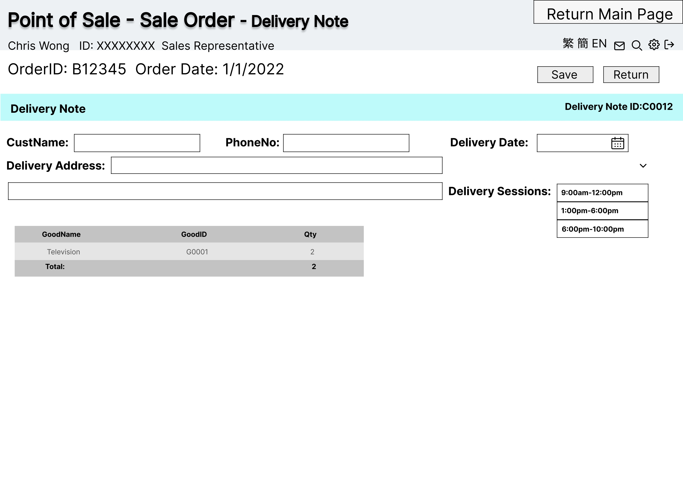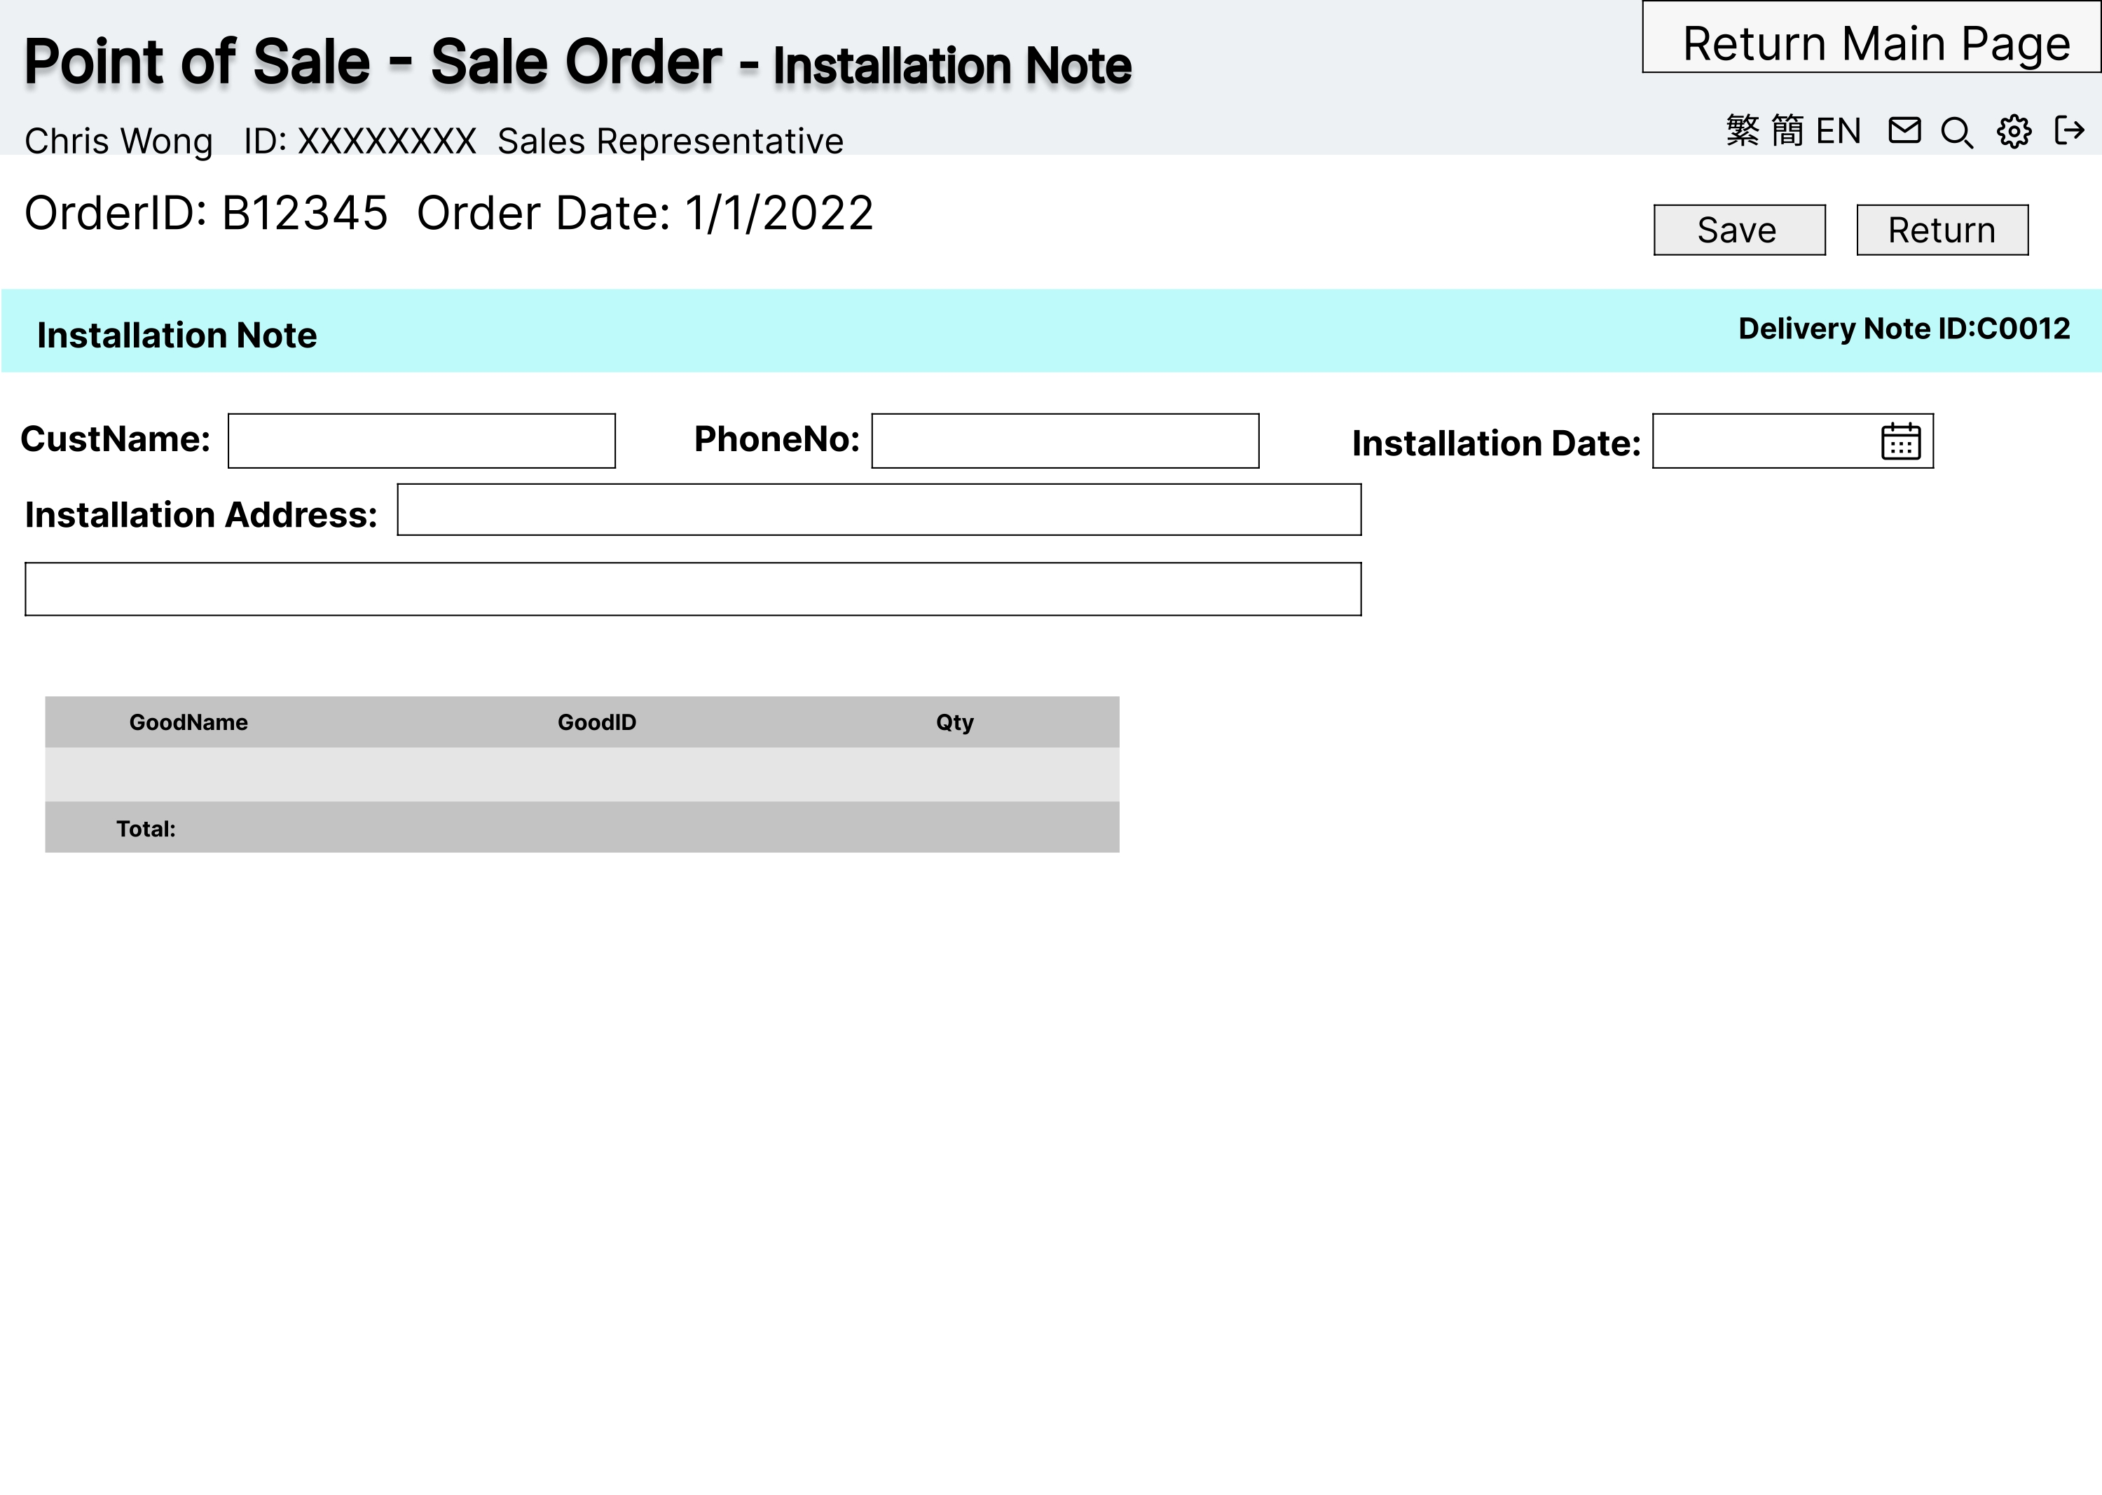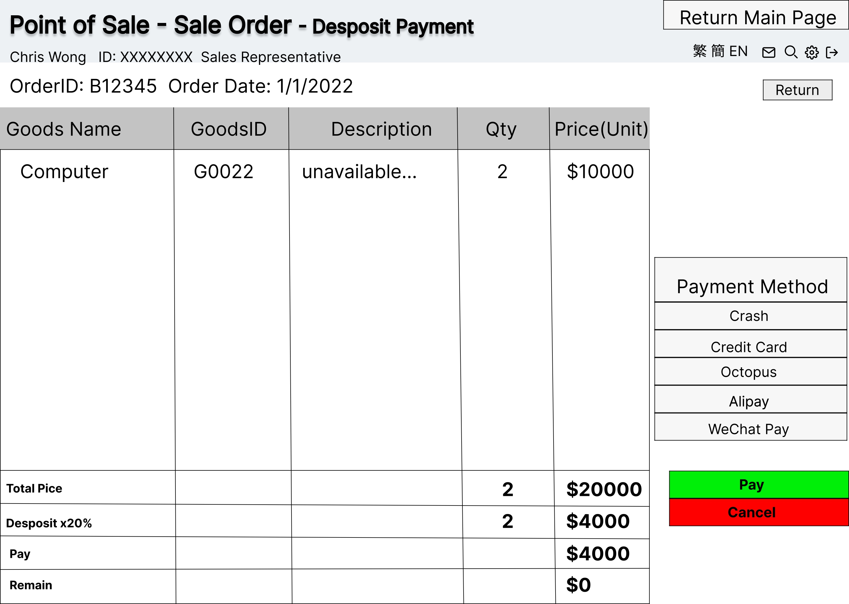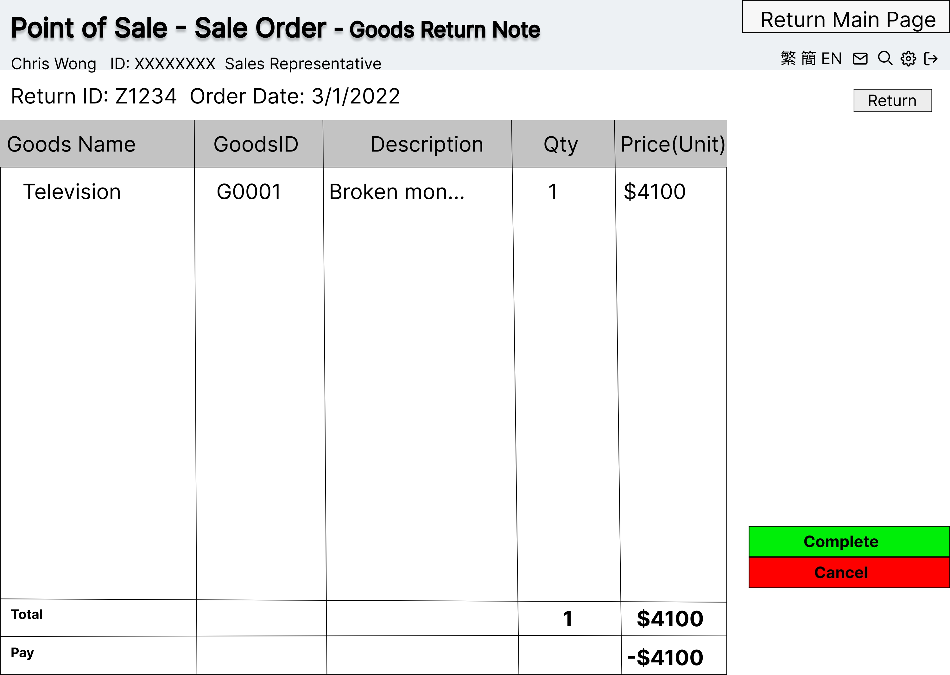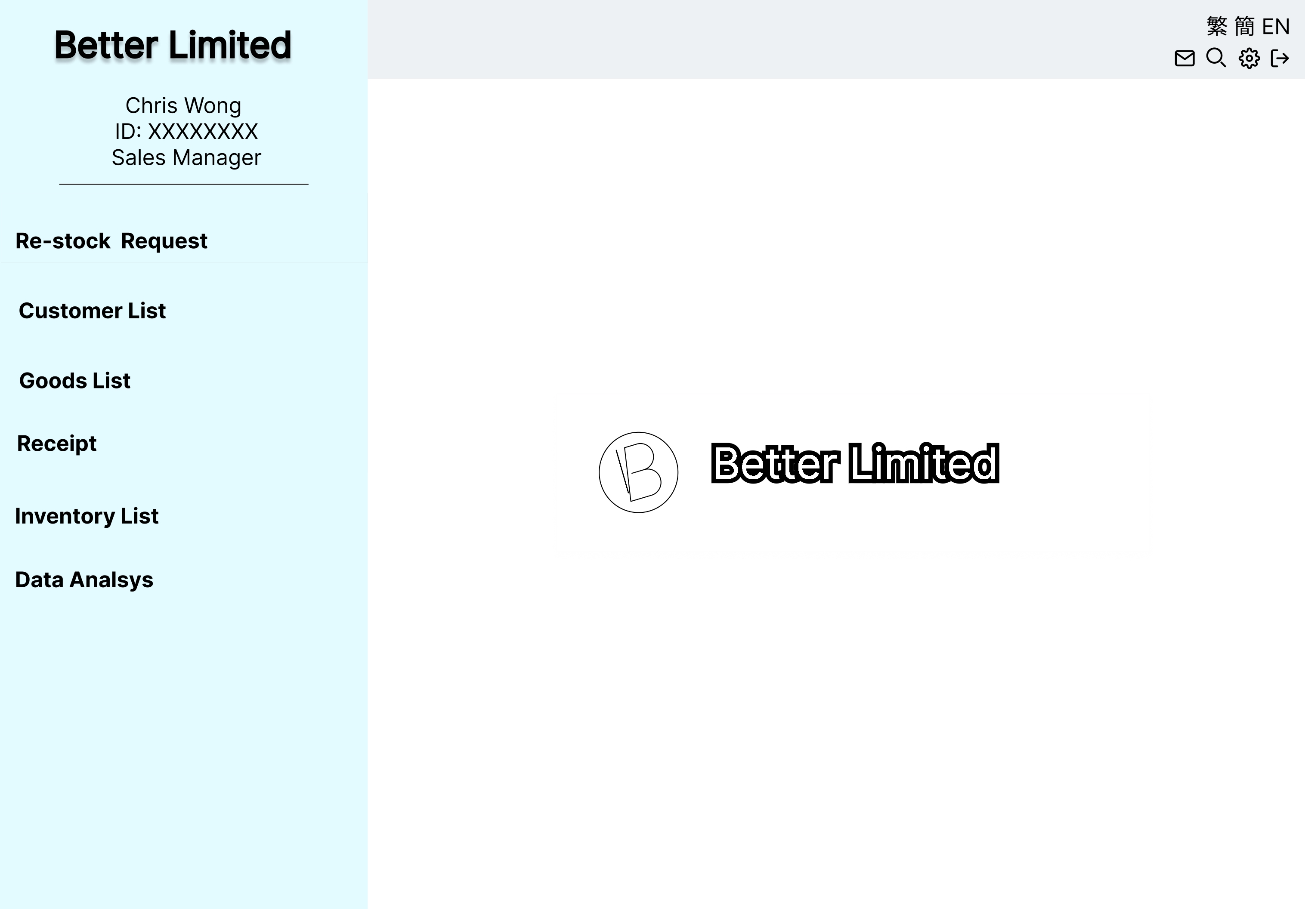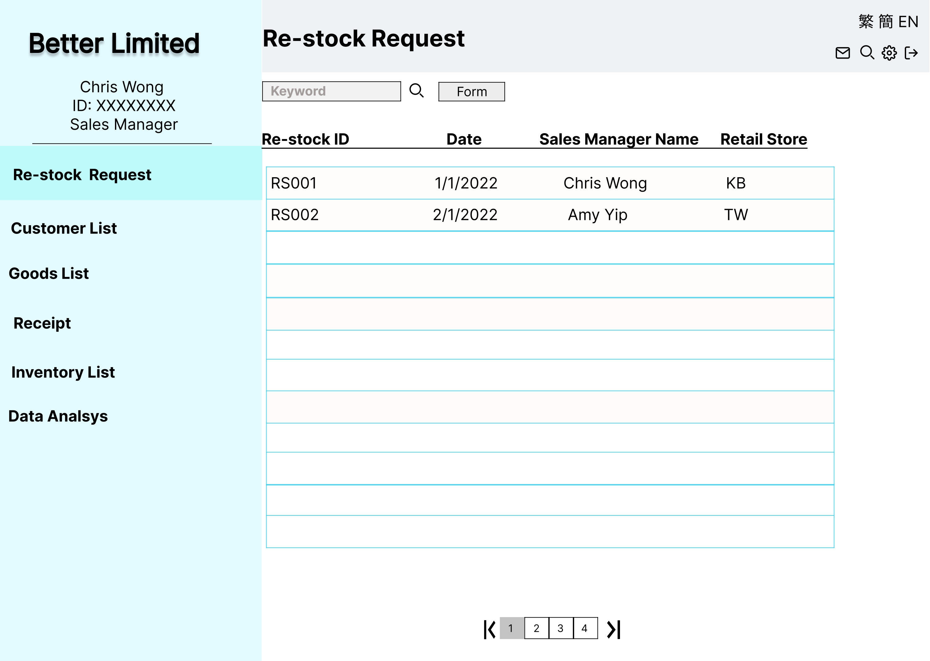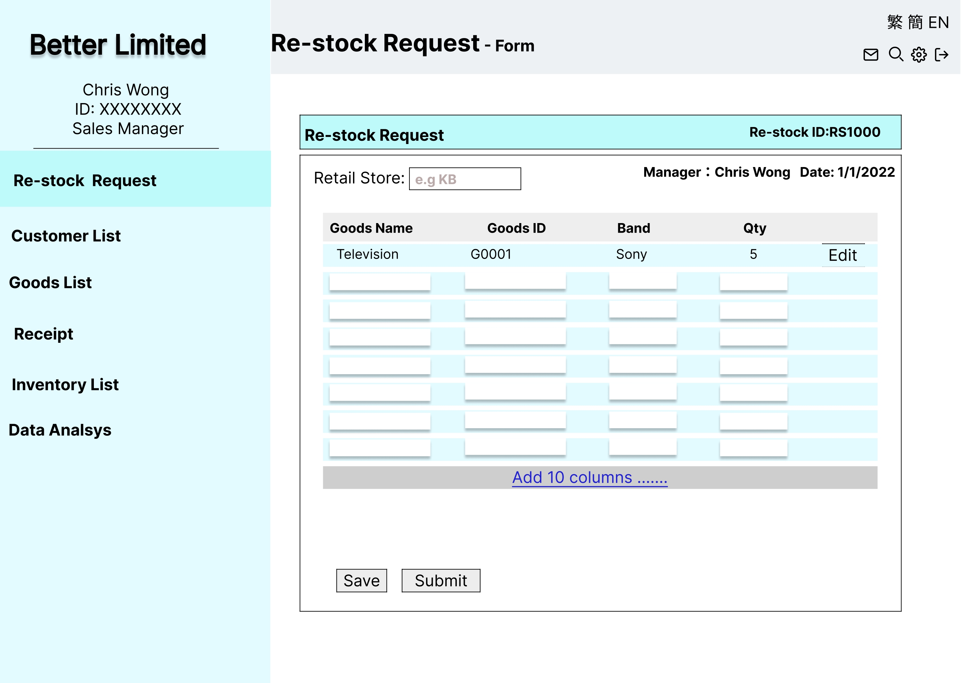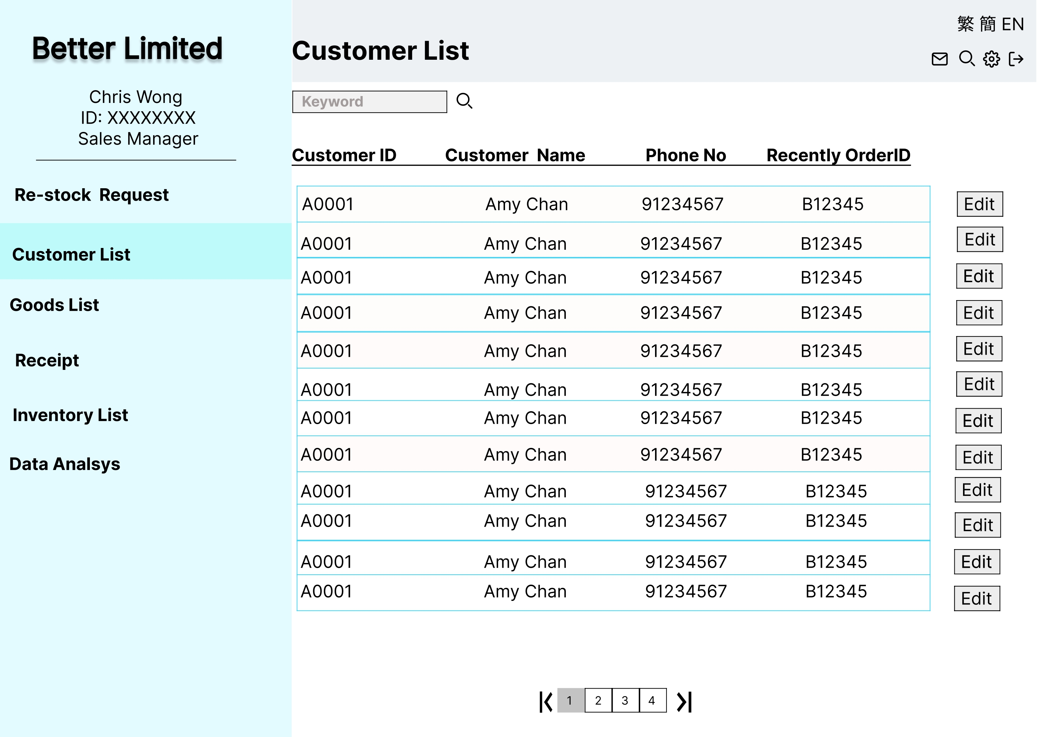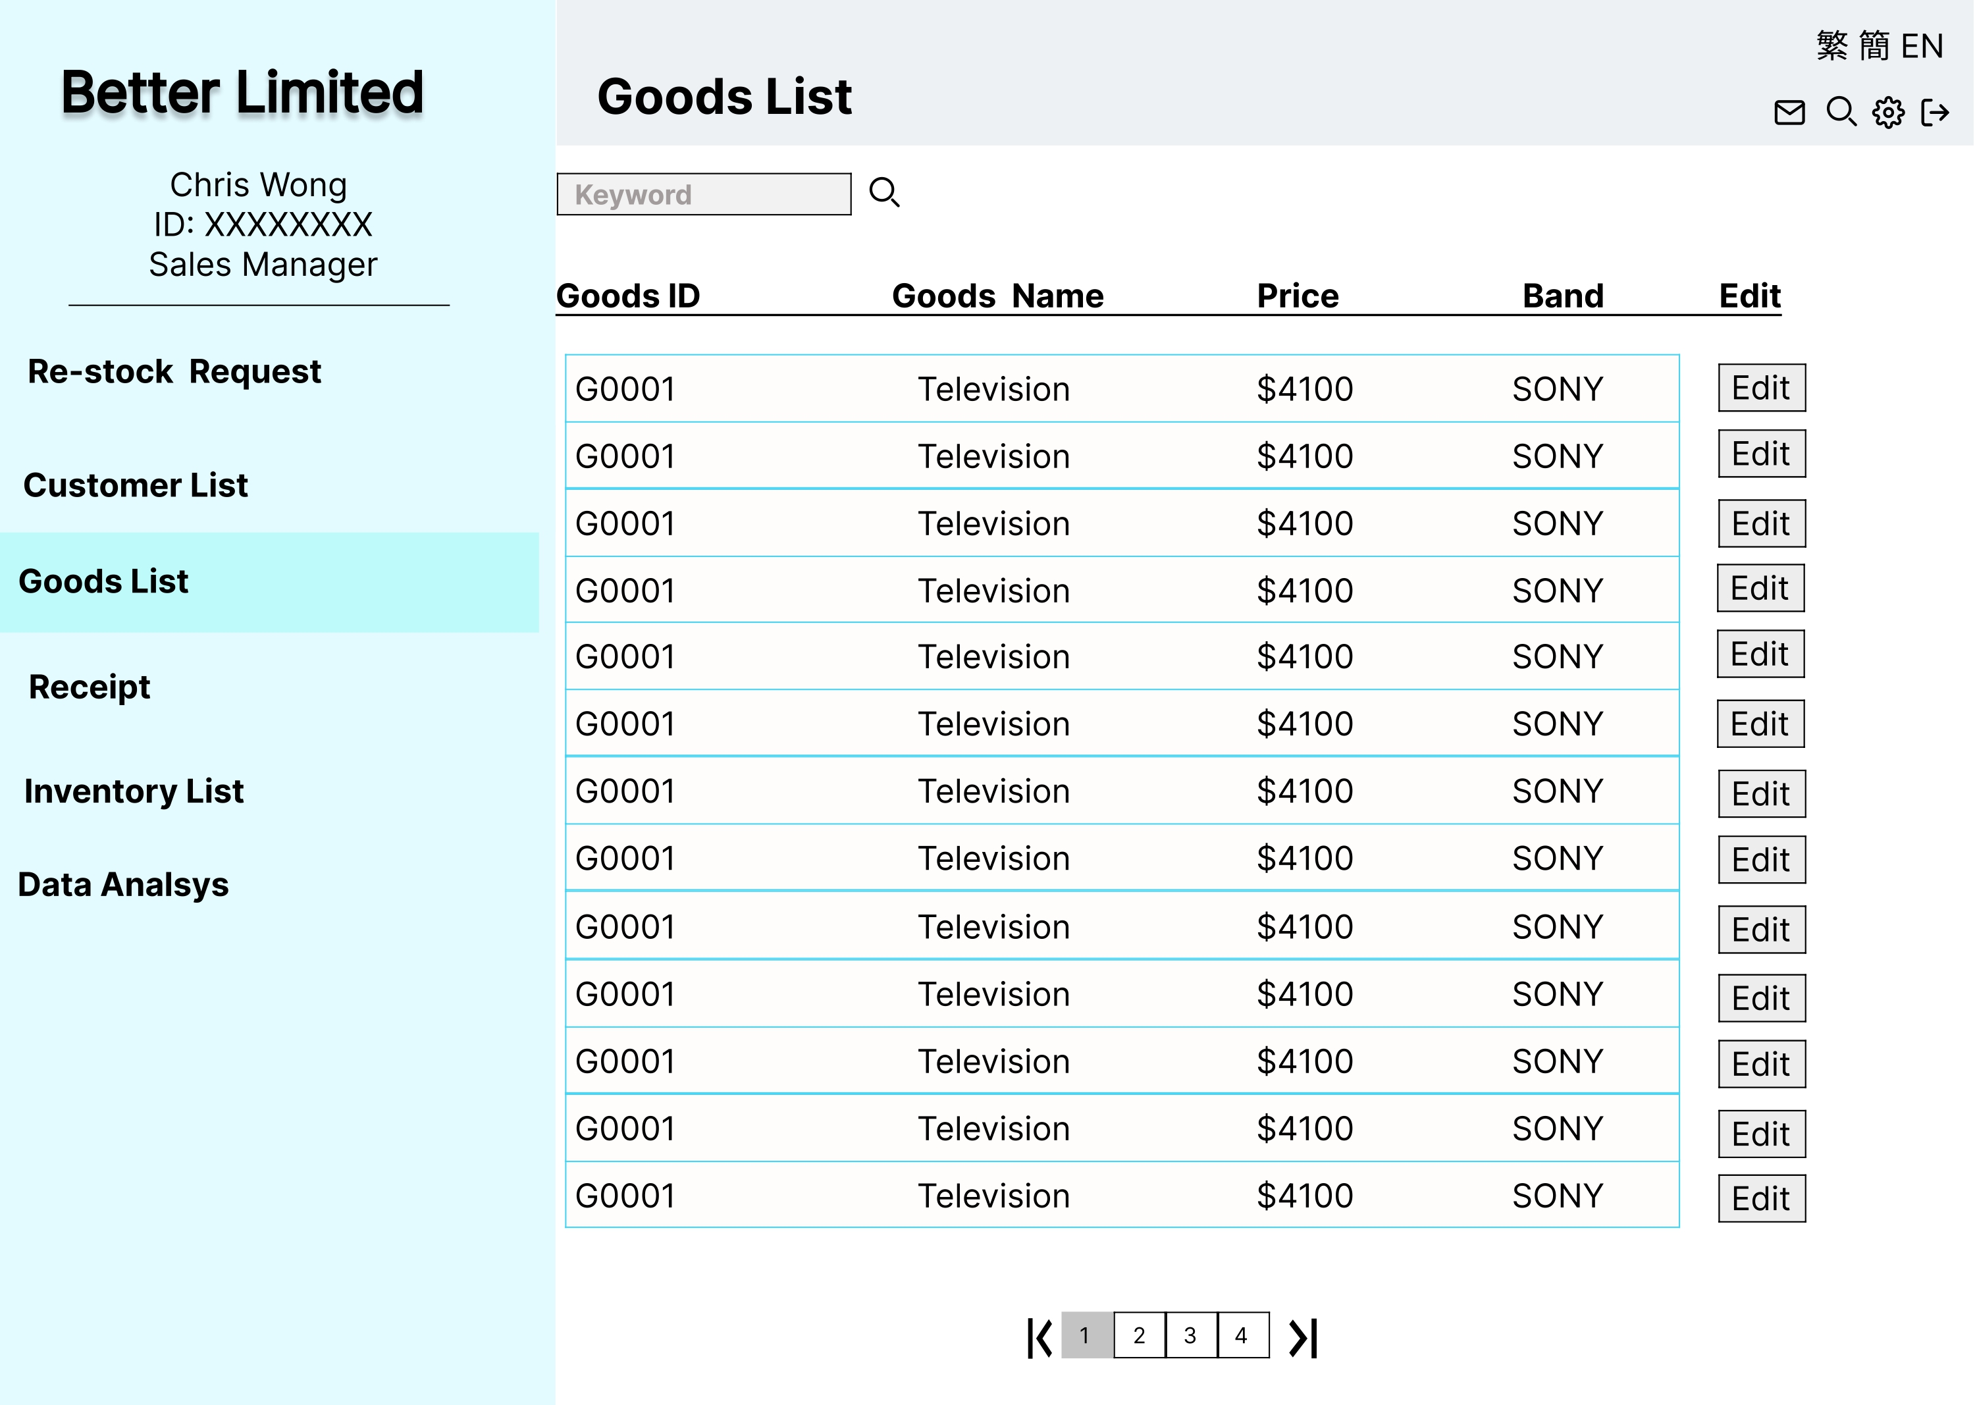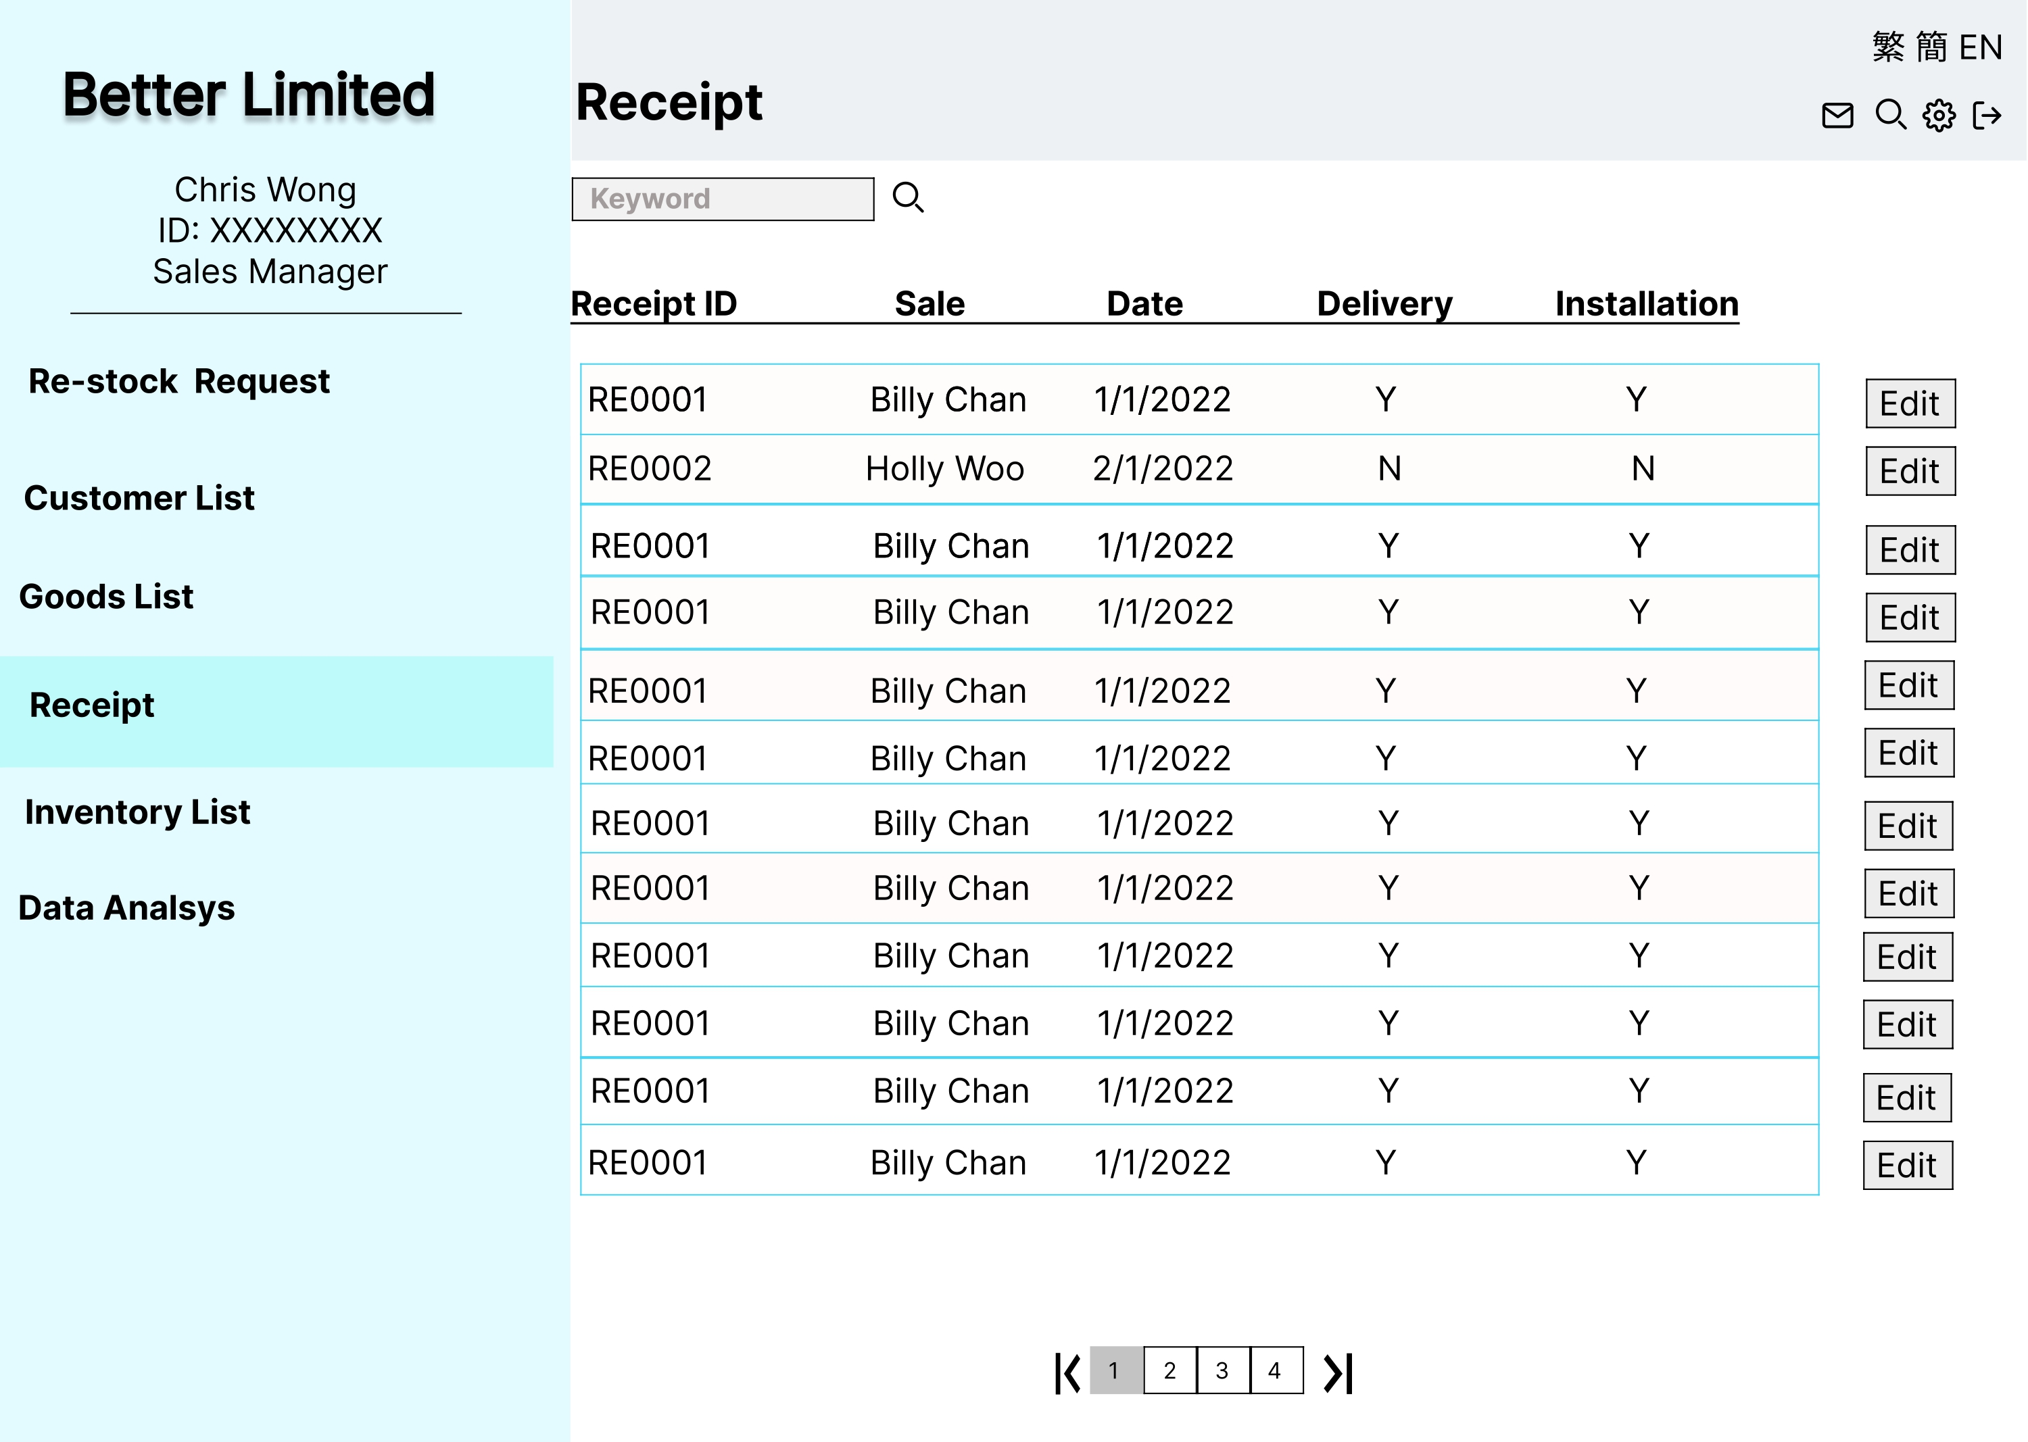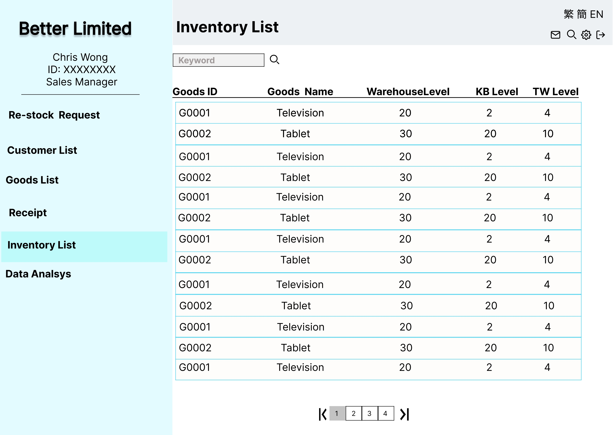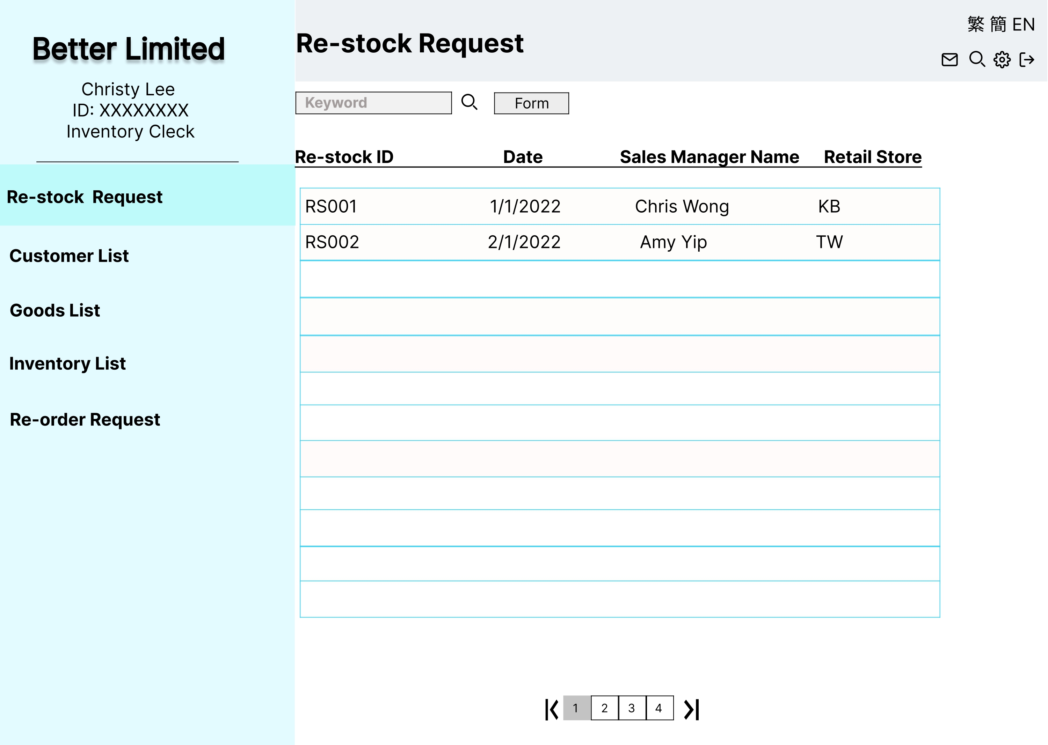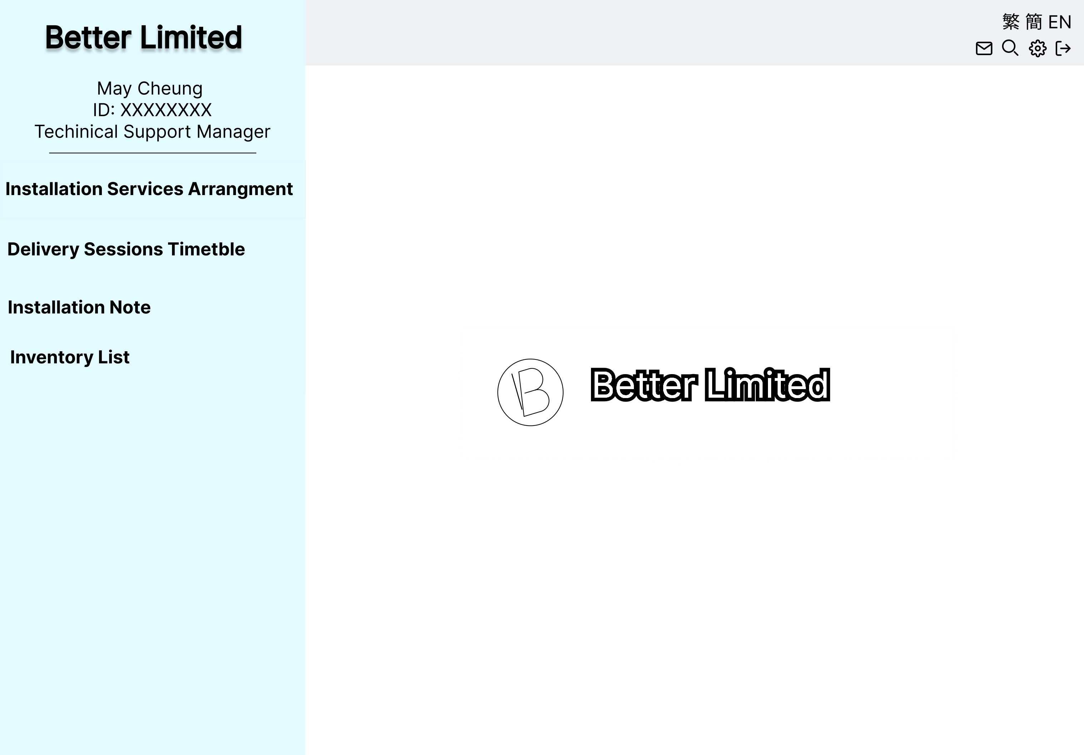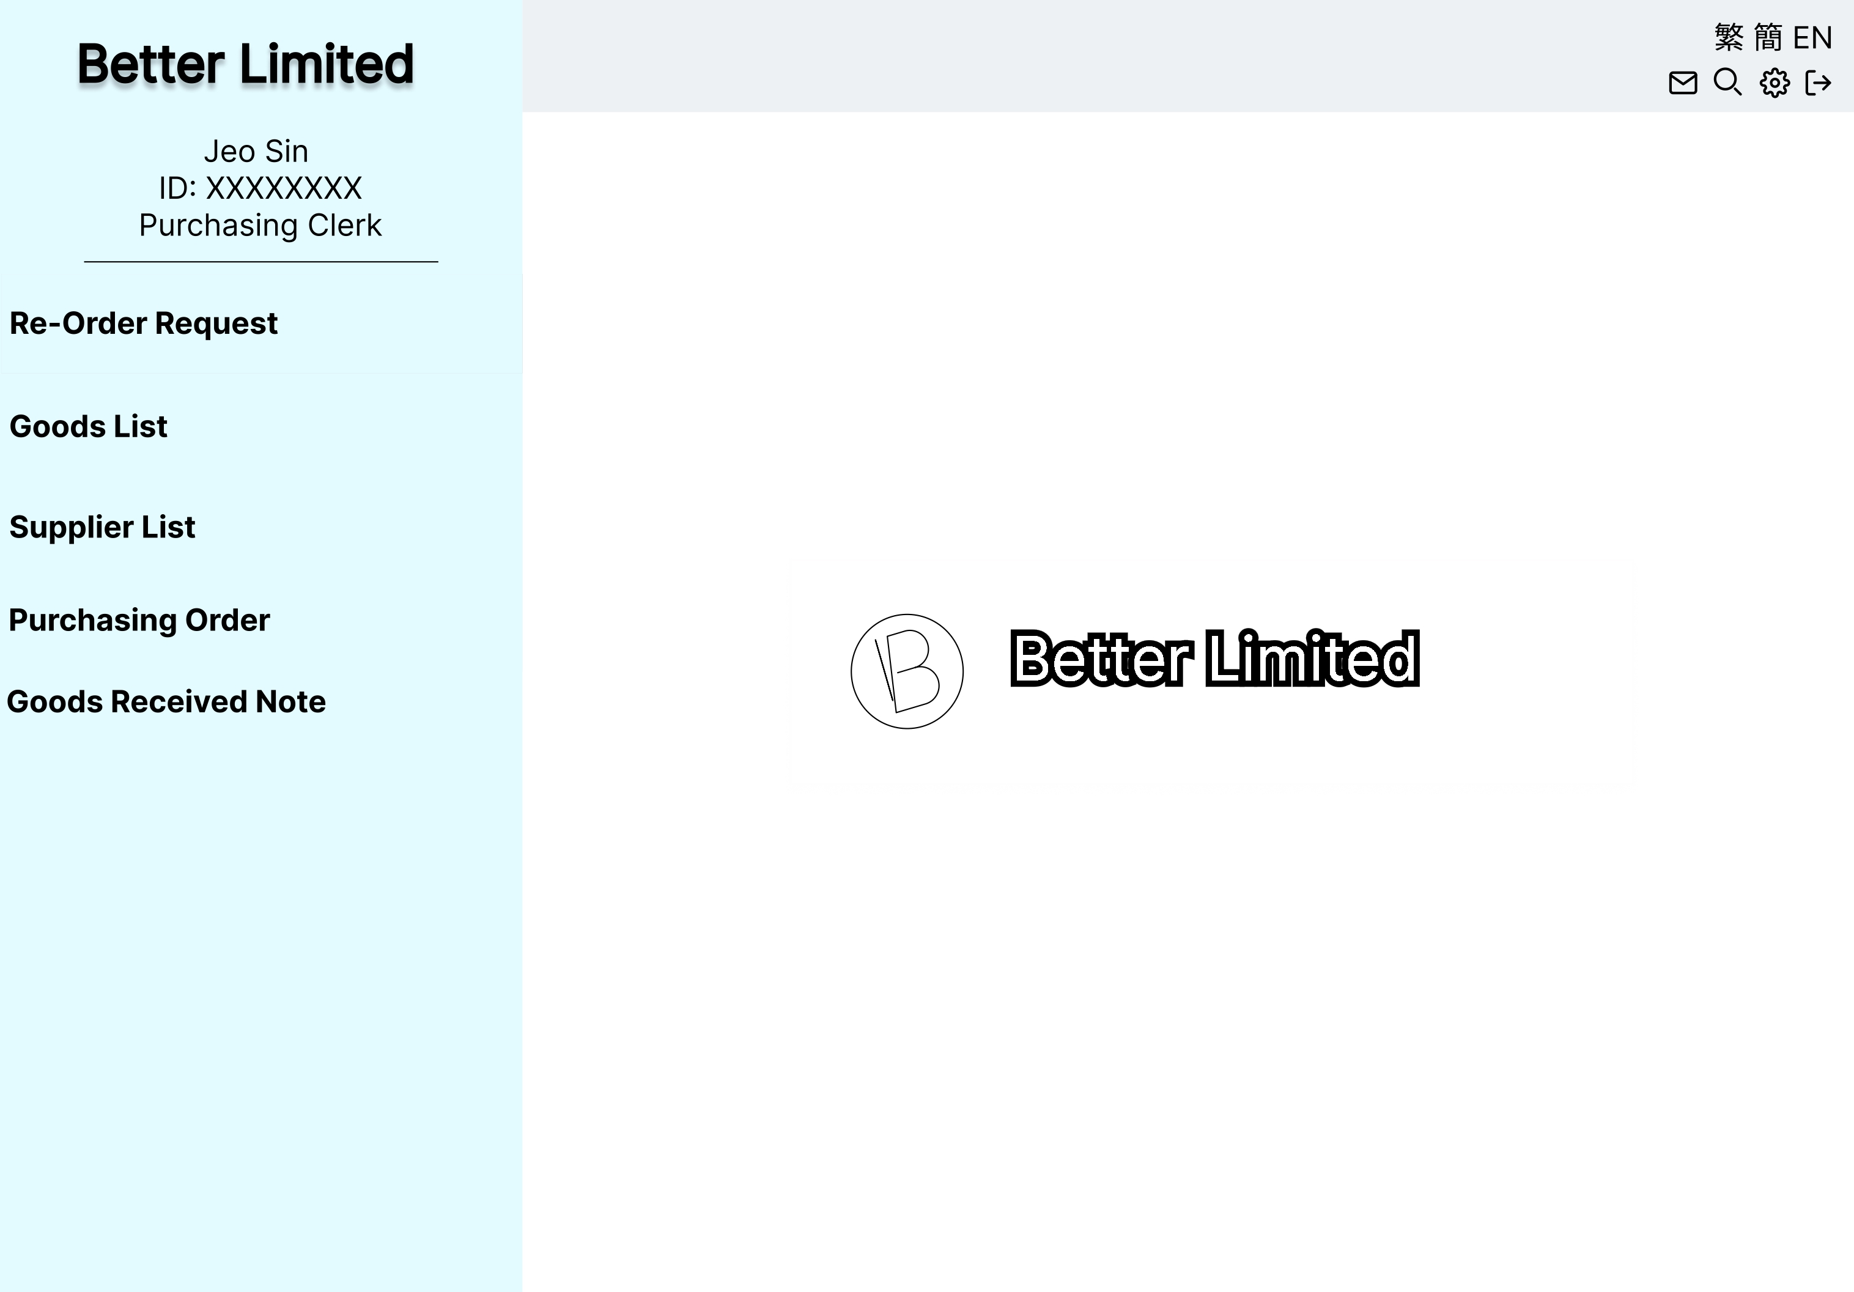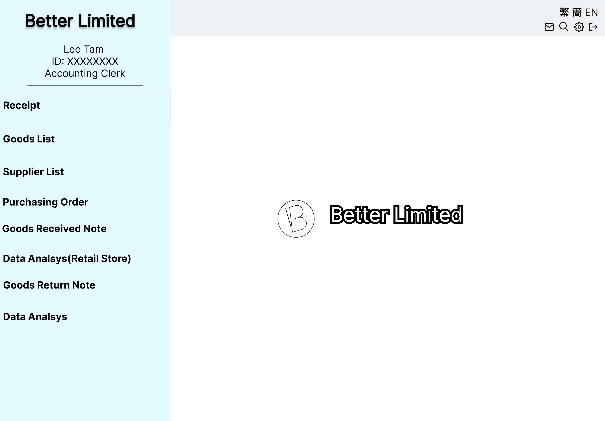

* 1. Application For Mobile And Tablet

**🡪**[**Prototype Link**](https://www.figma.com/proto/argZNrXTBtfxw4jTEZi3Kx/Better-Limited?node-id=29%3A49&scaling=scale-down&page-id=1%3A50&starting-point-node-id=29%3A49)**🡨**

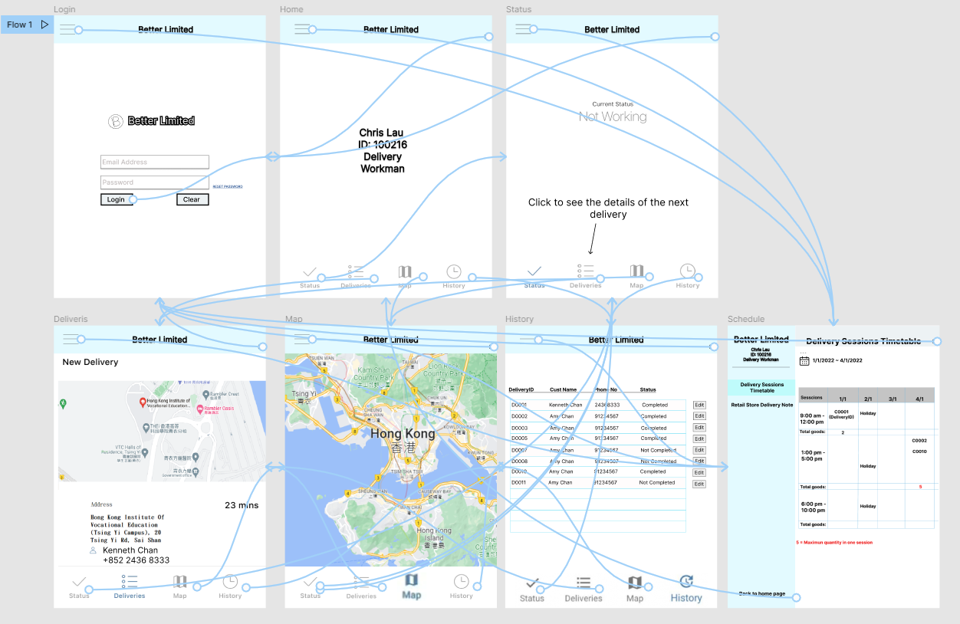

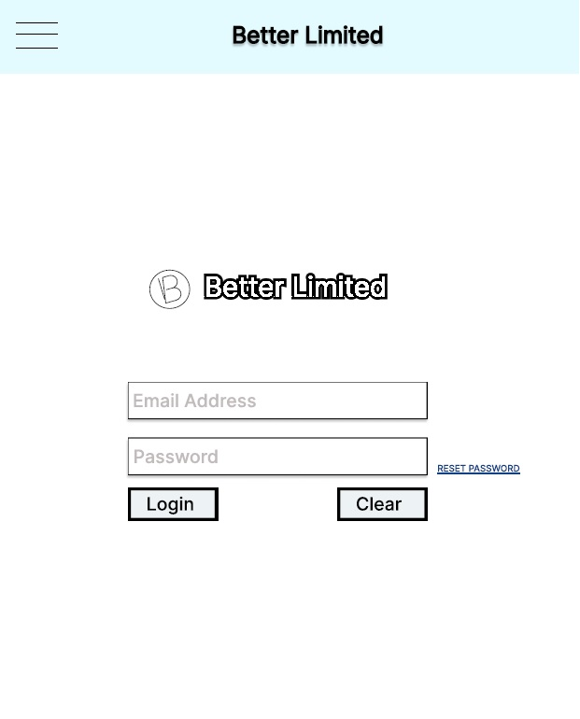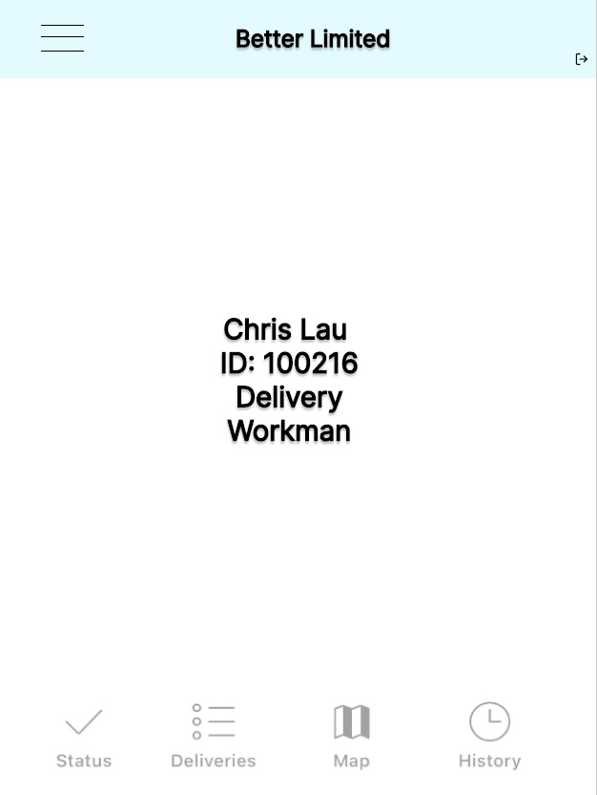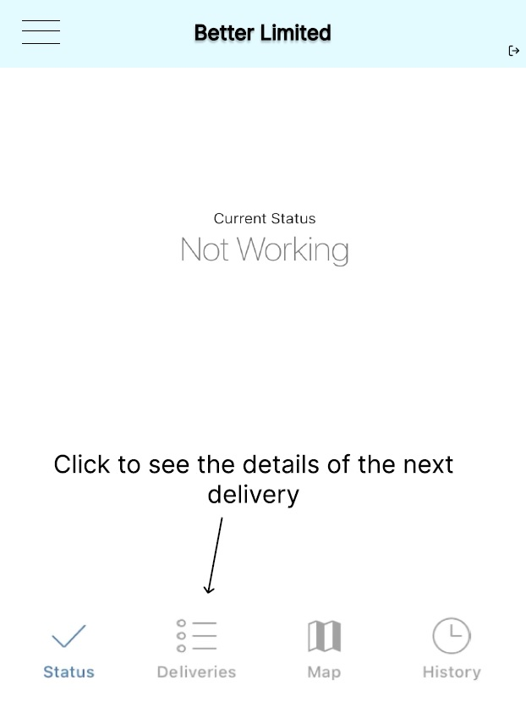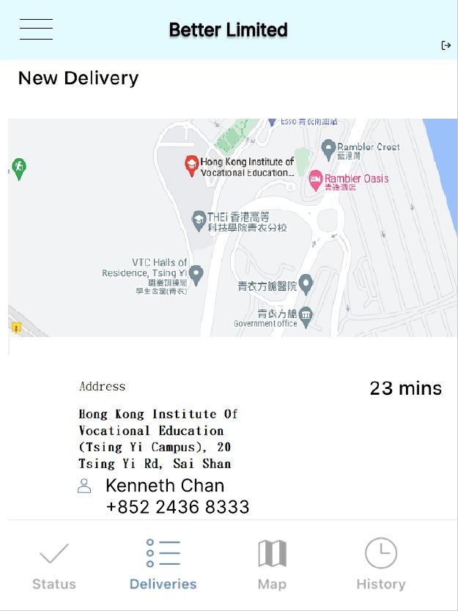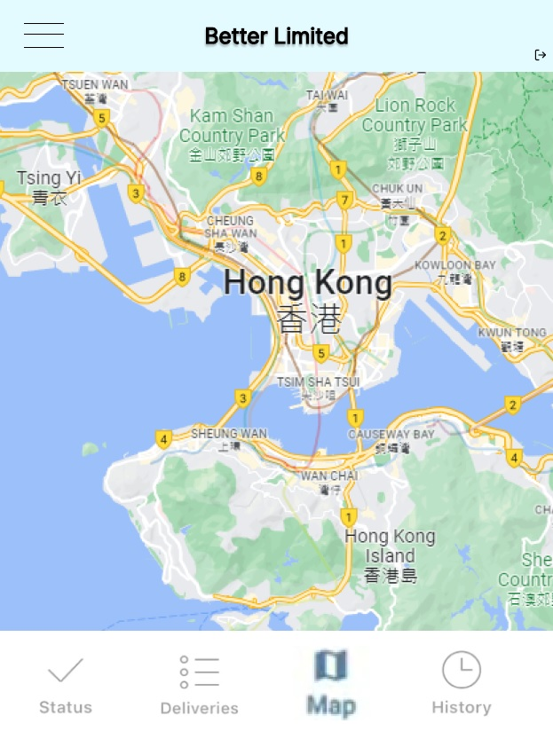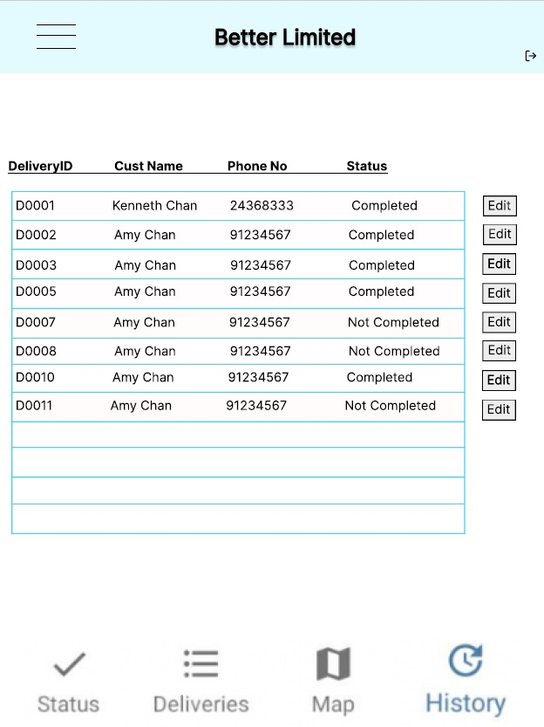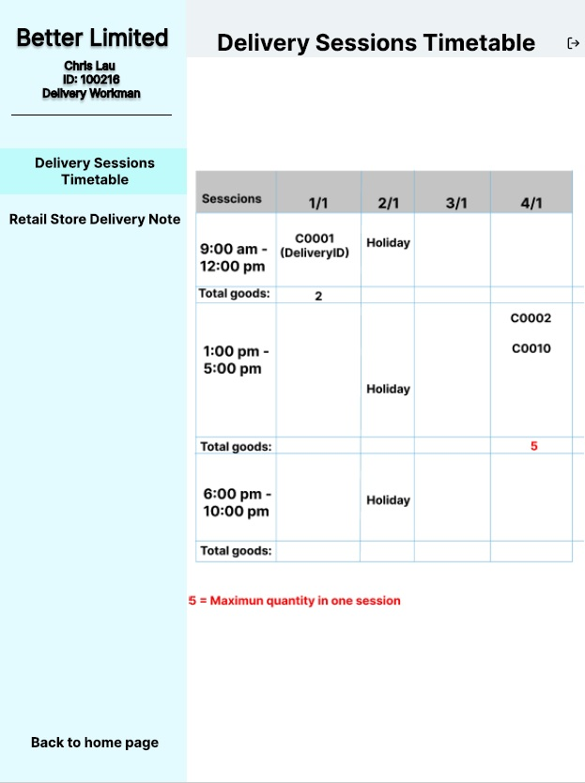

* 1. Online Store

